Belvue school
Govenors induction pack
October 2021

Contents

Introduction 3
What is a governor? 4
Roles and Responsibilities: 6
An overview of the responsibilities of the governing body: 7
Governor Competencies: 8
Governors Code of Conduct 9
Roles of Clerk, Chair and Head 12
Meetings 13
Time and commitment 14
Time for Duties 14
Governor Allowances 14
Conflicts of Interest 14
Our scheme of delegation 15
Governor Monitoring Visits and Link Governor Information 15
Child Protection Policy 15
Health and Safety Policy 16
TRAINING AND RESOURCES 17
Conclusion 19
PART TWO – What you need to know about Belvue School 20
Vision and Values 20
School Priorities 20
Area Demographics 21
BELVUE SCHOOL – AUTUMN 2021 22
Belvue Pupil SEN Needs Data 23
School Structure and Staff Team 25

Introduction
Welcome to Belvue School. We are delighted to have you join our Governing Body and look forward to the contribution you will make to our thriving learning community. Belvue School serves a community of extraordinary young people with Special Needs who are some of the most disadvantaged, yet inspiring young people in Ealing. In becoming a school governor, you are taking on one of the most important and valuable roles in education – the strategic leadership of a school. To help you understand your role, you will be given a good deal of information. It is important that you don’t feel swamped by this, but see it as background and reference to help you fulfil your undertaking and, enhance the lives of our young people.
Shelagh O Shea, the headteacher of the school and officers of the local authority (LA) can provide professional advice and support. Governors can develop their own knowledge through training schemes and other materials available locally and nationally.
Allison Blair
Chair of Governors

Induction
Some principles:
- induction should be seen as an investment, leading to more effective governance and retention of governors
- it should be welcoming, informative and helpful in getting a feel for the roles and responsibilities of the governing body
- it should promote the partnership between governing bodies, teachers, parents, pupils and the Local Authority (LA)
- it offers a generic introduction which leads on to specific areas of responsibility, see Appendix 1
- Being a a governor is about focusing on the needs of all pupils and not an individual child or your own child if you are a parent governor. Any concerns regarding your own child should be addressed via the school, following the normal protocols.
As a new governor it is reasonable to expect:
- an informal, friendly talk with the headteacher, followed by a more extended visit and tour of the school – in the working day, if possible
- a phone call from the chair, welcoming you and giving an update on current issues
Ideally at your first meeting
- the Chair introduces all governors, informally, including brief background details
- governors have name cards
- the Chair will explain all acronyms and jargon and explain the context of each major agenda item
- you may be asked to take on the role of a lead Governor for an area of school monitoring

What is a governor?
Someone who is part of the largest volunteer group in the country for a start!
What do they do?
The purpose of the governing body is to help the school to provide the best possible education for its pupils. They set the school aims and policies together with the head. The head is responsible for day-to-day management. Governors have responsibilities in such areas as curriculum, finance, personnel and special educational needs. No individual governor has any power unless delegated by the governing body. The governing body as a whole is responsible for any decisions made.
What kind of people are governors?
It’s a common misconception that all governors are ‘professionals’. Although governing bodies do find it helpful to have governors with skills in particular areas (e.g. finance or management skills) but most are ‘ordinary’ members of the public. As a governor you will be able to use your own experience of education and life beyond school to inform conversations, develop and utilise your skills in a board level environment, make a valuable contribution to education and your community, support and challenge the school so that it improves for pupils and staff, and bring your unique experiences, perspectives and insights into decision making in the interests of the school community.
Who cannot be a governor?
A person is disqualified from holding or from continuing to hold office as a governor or associate member for the following reasons:
- Are a registered pupil at the school
- Are under 18 years old
- Fail to attend their meetings for a continuous period of 6 months, without the consent of the governing board
  - This applies to all governors except ex-officio governors, such as the headteacher
  - If you're struggling with governor attendance read how to effectively manage the non-attendance of governors
- Are the subject of:
  - A bankruptcy restrictions order, or an interim bankruptcy restrictions order
  - A debt relief restrictions order, or an interim debt relief restrictions order
  - A sequestration that has not been discharged, annulled or reduced
- Have been disqualified from being a company director
- Have been disqualified from being a charity trustee
- Have been removed from office as an elected governor within the last 5 years
- Are included in the list of those unsuitable to work with children
- Are disqualified from working with children, barred from regulated activity and/or disqualified from registering for childminding or providing day care
- Are disqualified from registration under Part 3 of the Childcare Act 2006
- Are subject to a direction of the Secretary of State under section 142 of the Education Act 2002, or to a section 128 direction
- Are disqualified from being an independent school proprietor, teacher or employee by the Secretary of State
- Have been sentenced to 3 months or more in prison (without the option of a fine) in the 5 years before becoming a governor or since becoming a governor
- Have received a prison sentence of 2 and a half years or more in the 20 years before becoming a governor
- Have at any time received a prison sentence of 5 years or more
- Have been fined for causing a nuisance or disturbance on school or educational premises in the 5 years before becoming a governor or since becoming a governor
- Refuse a request by the clerk to make an application to the Disclosure and Barring Service (DBS)
This, and further detail on when these points apply, is set out in:
- Schedule 4 of The School Governance (Constitution) (England) Regulations 2012
- Regulation 6 of The School Governance (Constitution and Federations) (England) (Amendment) Regulations 2014
- Regulation 2 of The School Governance (Constitution and Federations) (England) (Amendment) Regulations 2017
- Pages 21 to 22 of the DfE's statutory guidance
There are additional disqualifications for particular types of governor. For example:
- Parent governors can't be:
  - Elected members of the local authority (LA), or
  - Paid to work at the school for more than 500 hours in a year at the time of election or appointment
- Local authority (LA) governors can't be members of the school staff
- Partnership governors can't be:
  - Parents of registered pupils at the school
  - Staff members
  - Elected members of the LA
  - Employed by the LA in connection with its education functions
- Staff governors are disqualified from holding office as a staff governor when they cease to work at the school
This is outlined on page 20 of the DfE's statutory guidance and regulations 5 to 8 of Schedule 4.
What type of governor could I be?
The composition of governing bodies is shown in the Instrument of Government for each school ensuring fair representation for different key groups with an interest in the school. Governors are appointed for a period of between 1 and 4 years (usually 4 years).
Liability
Although being a school governor may at first seem a heavy responsibility, you need to remember that an individual governor has no responsibility or power unless it is delegated to that individual by the governing body. The governing body is a corporate body of which you are a part. Personal claims against school governors are very rare indeed. Governors acting honestly, reasonably and within their powers will not incur personal liability. But should such an action take place, you can expect to receive full support from the school if your action have been in keeping with your role as a Governor of the school. Legal support from the school will also be available . However, a Governor maybe asked to resign if they fail to comply with the principles of public service expected from their role.

Roles and Responsibilities:

The School Governance Regulations 2012 set out the rules on how the board must be made up, and who can be on it. The DFE published statutory guidance on these regulations, which makes them easier to understand. The constitution of governing bodies of maintained schools (publishing.service.gov.uk)
Belvue School Instrument of Governance was ratified on 7th August 2014. (Appendix 1) The Full Terms of Reference for our school are published on the school website Governance | belvue (belvueschool.com)

Governing Bodies have three core functions as follows:

- Ensure clarity of vision, ethos and strategic direction
- Hold executive leaders to account for the educational performance of the school/trust and its pupils, and the performance management of staff
- Oversee the financial performance of the school/trust and make sure money is well spent

The Ealing Learning Partnership have produced an introductory briefing for new governors on the core functions PowerPoint Presentation (egfl.org.uk)

Governors’ responsibilities are detailed in The Governance Handbook for Academy Trusts and Maintained Schools and is updated annually. The most recent version is October 2020. Governance Handbook 2019 (publishing.service.gov.uk) This is not the legislation itself but it sets out the core roles and functions of the governing board, summarises all the legal duties on boards, signposting to the more detailed information, guidance and resources, and provides information on the support available for boards to be effective.

The Governing Body are responsible for ensuring statutory compliance in the following areas:
- Admissions
- Behaviour and exclusions
- Curriculum
- Finance
- Governance
- Parents and the community
- Health and Safety
- Pupil Wellbeing
- Safeguarding
- Special educational needs and disabilities (SEND)
- Staffing
- Pay and Appraisal

The Key for School Governors has produced a helpful checklist of all schools statutory responsibilities which includes the links to all the relevant statutory guidance. (Appendix 2)

An overview of the responsibilities of the governing body:

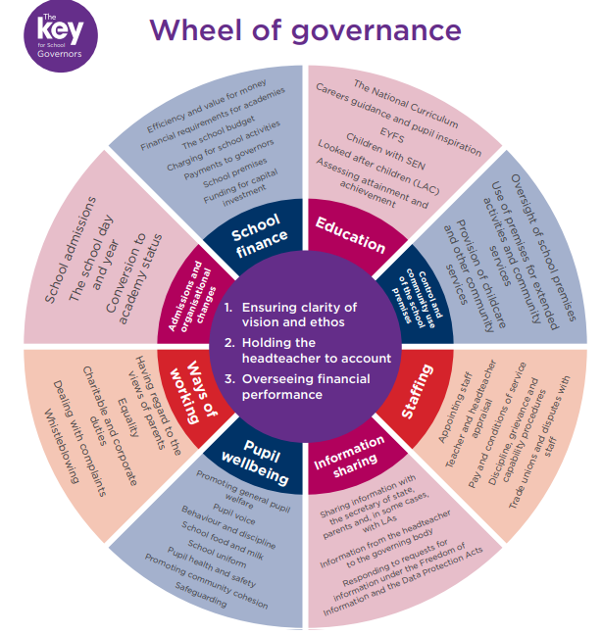

Governor Competencies:

The Governance Handbook should be read in conjunction with A Competency Framework for Governance published in 2017 A competency framework for governance (publishing.service.gov.uk).
The framework is made up of 16 competencies underpinned by a foundation of important principles and personal attributes. The competencies are grouped under the headings of the six features of effective governance, which are set out in the governance handbook: strategic leadership, accountability, people, structures, compliance and evaluation. The guidance provides a useful breakdown of the knowledge, skills and effective behaviours required by all board members for each of the 16 compentencies as well as the specific knowledge, skills and effective behaviours required by the Chair.

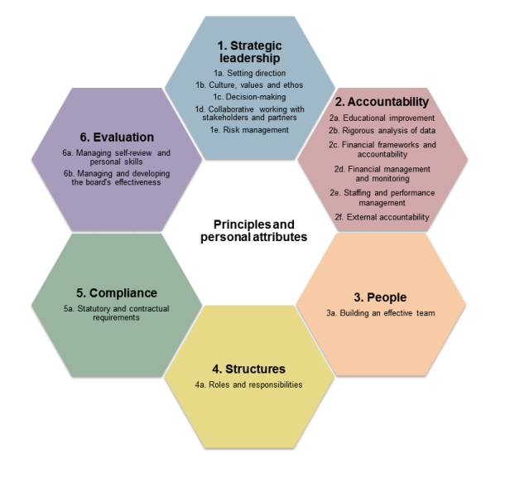
The principles and personal attributes that individuals bring to the board are as important as their skills and knowledge. Governors must always be mindful of their responsibilities under equalities legislation, recognising and encouraging diversity and inclusion. The should understand the impact of effective governance on the qulity of education and on outcomes for children and young people. In addition all those involved in governance should be:
- Committed Devoting the required time and energy to the role and ambitious to achieve best possible outcomes for young people. Prepared to give time, skills and knowledge to developing themselves and others in order to create highly effective governance.
- Confident Of an independent mind, able to lead and contribute to courageous conversations, to express their opinion and to play an active role on the board.
- Curious Possessing an enquiring mind and an analytical approach and understanding the value of meaningful questioning.
- Challenging Providing appropriate challenge to the status quo, not taking information or data at face value and always driving for improvement.
- Collaborative Prepared to listen to and work in partnership with others and understanding the importance of building strong working relationships within the board and with executive leaders, staff, parents and carers, pupils/students, the local community and employers.
- Critical Understanding the value of critical friendship which enables both challenge and support, and self-reflective, pursing learning and development opportunities to improve their own and whole board effectiveness.
- Creative Able to challenge conventional wisdom and be open-minded about new approaches to problem-solving; recognising the value of innovation and creative thinking to organisational development and success.

Governors Code of Conduct

Our code of conduct aims to set and maintain standards of conduct that we expect all governors to follow.
We aim to ensure that governors carry out their role with honesty and integrity, and help us to ensure our school is an environment where everyone is safe, happy and treated with respect. We will follow these principles (The 7 Nolan Principles) which apply to anyone who holds a public office:
Selflessness – we will act in the public interest
Integrity – we will not act or take decisions to gain financial or other material benefits for ourselves, our family, or our friends. We will declare any conflict of interests
Objectivity – we will act and take decisions impartially, fairly, and on merit. We will use the best evidence and avoid discrimination or bias
Accountability – we understand that we are accountable to the public for our decisions and actions. To make sure of this, we will be scrutinised where necessary
Openness – we will act and take decisions openly and transparently. We will not withhold information from the public unless there are clear and lawful reasons for doing so
Honesty – we will be truthful
Leadership – we will actively promote and support the above principles and will challenge poor behaviour wherever it happens.

We will focus on our core governance functions:
- ensuring there is clarity of vision, ethos and strategic direction
- holding executive leaders to account for the educational performance of the organisation and its pupils and the performance management of staff
- overseeing the financial performance of the organisation and making sure its money is well spent.

As individuals on the board we agree to:

Roles and responsibilities
      - Always act in the best interests of the school and all its pupils
- Know, understand and work within the prescribed regulatory framework
- Accept that no governor has the legal authority to act alone except in exceptional circumstances as prescribed in the regulations or if the full GB has delegated authority
- Act fairly and without prejudice, and in so far as the GB has responsibility for staff including the headteacher/executive leader/s, fulfil all that is expected of a good employer
- Understand, accept and respect the difference in roles between the GB, staff and senior leaders, ensuring that the GB work collectively for the benefit of the school/s
- Consider carefully how GB decisions may affect the community and other schools
- Always be mindful of the GB’s responsibility to maintain and develop the ethos and reputation of the school/s
- When formally speaking or writing as a governor, ensure our individual comments reflect current school/s policy and in our private capacity (including social media) strive to uphold the reputation of the school/s.

Confidentiality
- Observe and respect confidentiality regarding all GB and school matters
- Not reveal the details of any GB vote outside of meetings
- Ensure all confidential papers, e mails and personal data are held and disposed of appropriately and in line with the school’s data protection policy (GDPR)
- Ensure that conduct on school visits conforms to agreed visits policy and safeguarding of children e.g. not record visit with photos or recording unless agreed/in line with school policy
- Report any evidence of fraud, corruption or misconduct to an appropriate person or authority
- Understand that the requirements relating to confidentiality will continue to apply after a governor leaves office.

Commitment
- Actively involve ourselves and accept our fair share of work/positions of responsibility as part of the full GB and of at least one committee as appropriate
- Attend all meetings promptly, regularly, and for the full time. Where we cannot, explain in advance to the clerk (Insert GB policy on authorised/unauthorised absences)
- Prepare for meetings by reading all relevant papers and preparing any questions or comments in advance of the meeting
- Ensure as individuals or collectively as relevant, we have followed up on any allocated actions from previous meetings and are able to report on as appropriate
- Get to know the school/s well and involve ourselves in school activities and visits – agreed and arranged in advance as part of the GBs priorities with the headteacher/senior leaders
- Take responsibility for our own learning and development as a governor including attending training – for this GB we will endeavor to attend at least three central Ealing and/or whole GB bespoke training sessions in addition to ongoing CPD
- Declare any pecuniary/business interests in the register of interests; and as relevant declare at the start of meetings any conflict of interest and abide by the GBs decision
- In the interests of transparency and open governance we understand the following will be
published on the school website and logged on the DfE national database of governors (GIAS):
- Our full names
- Dates of appointment
- Terms of office
- Roles on the GB
- Attendance records
- Relevant interests
- Category of governor, and
- The body that appointed us.
- Undertake a DBS check within 21 days of appointment and if appropriate a barred list check and section 128 check
Relationships
- Work as a member of a team always and accept collective decisions made by the GB. This means not speaking against any majority decisions outside the GB even if different from our own individual opinions
- Be polite, courteous and professional at all times
- Listen to and respect the views of others
- Act fairly and without prejudice
- Contribute to every meeting as appropriate, expressing our views clearly and succinctly, making contributions through the chair
- Seek to develop effective working relationships with the headteacher, staff and parents, the local authority, community and other relevant agencies.

Breach of this code of conduct
- If we believe this code has been breached, we will raise this issue with the chair and the chair will investigate; the GB will only use suspension/removal as a last resort after seeking to resolve any difficulties or disputes in more constructive ways
- Should it be the chair that we believe has breached this code, another GB member, such as the vice chair will investigate.

Roles of Clerk, Chair and Head
Clerk to the Governors
Every governing body must appoint a clerk. Clerks organise and minute meetings, maintain records of membership, attendance and appointments and should also advise the governors on constitutional issues, statutory duties and powers. Governors, associate members and the head cannot be appointed as clerk to the governing body. The Clerk to Belvue School’s Governing Body is Frank Curry - f.curry@btinternet.com
Chair of Governors
The chair is elected each year by the governors. It is considered good practice for a chair to serve no more than six years in the role at one school (under normal circumstances). The chair leads the governing body and should ensure that it fulfils all its statutory responsibilities. A good chair will build an effective team, ensuring that all governors participate fully in meetings and committees and developing their knowledge, confidence and skills. He or she needs to have a close, trusted, supportive, though not exclusive relationship with the head. The current Chair of Governors is Allison Blair – allisonb@belvue.ealing.sch.uk
The vice-chair acts as chair when the chair is unavailable, and assumes the role of chair if the current chair resigns between meetings. Chairs and vice-chairs should decide between themselves how the workload is divided between them according to individual areas of interest and expertise. Governors who are paid to work at the school cannot be elected as chair or vice chair. This post is currently vacant.
Head
In a well-managed school, the headteacher and governing body work in close partnership. The head has responsibility for the internal organisation, management and control of the school and for implementation of the strategic framework established by the governing body. Governors are not expected to be involved in the detail of the day-today management of the school: that is for the head. A good governing body will delegate enough powers to allow the head to perform his/her management duties as effectively as possible. The head must report to the governing body regularly on how those delegated powers have been exercised.

Examples:
Area of responsibility | Governing Body | Head
Policies | Agree | Implements
Performance Management of head | Set objectives and review head’s progress against them | Meets or fails to meet objectives
Appointments | Appoint head | Appoints other staff

The head is automatically a governor unless he/she informs the clerk at the first meeting of the school year that he/she does not wish to serve as a governor.

Meetings
Full governing body meetings:
- There must be at least 3 full meetings each school year, at Belvue we schedule 6 meetings annually
- The governing body, the chair or any 3 governors can call an extra meeting
- The procedure for electing chair and vice chair shall be determined by the governing body to include the period of office (between 1 and 4 years). An employee of the school, associate member or a pupil at the school is not permitted to be chair or vice chair of the full governing body
- The governing body decides who else may attend its meetings
- A governor can become disqualified from holding office on the governing body if, without the consent of the governing body, they fail to attend a full governing body meeting for a continuous period of 6 months starting from the date of the first meeting they failed to attend. Clerks are responsible for recording whether an absent governor(s)’ apologies (if offered) are accepted by the governors present, at each meeting
Before
- Written notice of a meeting, the agenda and any associated papers are sent to governors 7 clear days in advance. When urgent action is needed the chair may determine that a shorter time scale is necessary
During
- A decision can only be taken if one-half (rounded up) of current membership is present
- Where there is equal division of votes the chair (or acting chair) has a casting vote
- The head and clerk have the right to attend all meetings of the governing body and its committees unless it is to discuss possible disciplinary action against them or their pay
After
- The clerk shall ensure that minutes are drawn up and signed (subject to the approval of the governing body) by the chair of the next meeting
- As soon as is reasonably practicable after the meeting, the agenda, papers considered and minutes of the governors’ meeting must be made available for persons wishing to inspect them

Governors’ meetings are well organised and effective when:
- there is a clear programme of meetings throughout the year
- meetings start and end on time and are purposeful
- the agenda and relevant papers are sent out well in advance
- the chair manages the meeting effectively and encourages the participation of others
- there is a balance between presentation, discussion and decision making
- the clerk has been trained to carry out the role
- the minutes are clear, accurate and include actions and who is responsible for carrying them out and are sent out promptly
Committee meetings
- the governing body decides its own committee structure, timings of the meetings and terms of reference of those committees. Currently the Governors have decided to run only one sub committee for Finance, Resource and Staffing, with the other areas of responsibilities being overseen by a system of allocated lead Governors. See Appendix 5
- an employee of the school or an associate member is permitted to be chair or vice chair of a committee.

Time and commitment
There are no laid down expectations, but governors are required to attend meetings (there are a minimum of 6 full governing body meetings per school year), read important papers, attend training and visit the school at least termly, when it is open. Recent national research suggests governors devote around 60 hours per annum to this role. The standard term of office for a school governor is four years but this can be extended.

Time for Duties

Governors are entitled to time off from work to carry out their role. Section 50 of the Employment Rights Act 1996 requires employers to permit employees who hold certain public positions reasonable time off to perform the duties associated with them. The employee and employer have to agree on what is reasonable time off. While there is nothing to prevent an employer from making payment to an employee for time off for public duties, there is no obligation for payment to be made. Time off work for public duties - GOV.UK (www.gov.uk)

Governor Allowances

The school follows the guidance in The School Governance (Roles, Procedures and Allowances) (England) Regulations 2013. Advice template (publishing.service.gov.uk) School governors provide a voluntary service and cannot be paid for their role as a governor. However they can receive out fo pocket expenses for reasonable travel costs or childcare. The governing body has therefore decided to pay reasonable allowances from the schools delegated budget to cover any costs that governing body members incur through carrying their duties. Our governors allowance policy sets out the terms on which such allowances will be paid. By adopting this policy, we will ensure that no member of the community is prevented from becoming a governor on the grounds of cost.

Conflicts of Interest

At Belvue School we want to ensure that the decisions taken by the governing body are free from personal bias, and don’t unfairly benefit any individual or company connected to the school. Our conflicts of interests and gifts and hospitality policies aim to ensure that:
- Everyone to whom the policy applies understands what a conflict of interest is
- Everyone to whom the policy applies understands their responsibility to identify and declare any conflicts of interest
- Every potential relevant conflict of interest, or perceived conflict of interest, is identified, recorded and prevented
- Decision-making isn’t affected by conflicts of interest
- There are clear procedures for managing conflicts of interest where these arise
All governors must complete a declaration of business and pecuniary interests declaration annually.
See Appendix 3 for full policy.

Our scheme of delegation

Our scheme of delegation sets out which committees will take decisions and carry out certain functions of the governing body. This can be found in the Schools Finance Handbook. (Appendix 4) The responsibilities of each committee are set out in its terms of reference.

We currently have one delegated committee, the Finance and Resources Committee. New governors are always very welcome to join the committee even if you have no finance experience.

Governor Monitoring Visits and Link Governor Information

The governing body should aim to inform their decision making by having visited the school at least three times during the school year. Governors should be aware of the feelings of members of staff and the issues they face by having had a more lengthy discussion with at least their link member of staff during the year.

A list of governor roles and responsibilities as well as the expectations around monitoring visits to the school are detailed in full in the Governors Monitoring Policy (Appendix 5).

Closer links between governors and staff has potential benefits for the whole school community including a deeper understanding of school life, opportunities to meet and chat with the children and young people, opportunities to meet staff and demonstrate governors commitment to the school, aware of the effects of change and different approaches to teaching and learning, seeing policies and schemes of work in action, seeing what resources are being used and gaining first hand information to assist with policy approval and decision making. Staff benefit by finding more about governors, can take pride in showcasing their practice, have opportunity to raise issues, reflect upon practice through discussion and gain support and feedback from a critical friend.

Governors should follow the protocols in the monitoring policy to ensure consistency and structure around the work they are undertaking and a monitoring visit form should be completed to effectively capture the relevant points from the visit. (template included in the policy)

Child Protection Policy

Safeguarding and child protection is everyone’s responsibility. This policy applies to all staff, volunteers and governors. Our policy and procedures also apply to extended school and off-site activities.
Our school’s child protection policy on the website at School Policies | belvue (belvueschool.com) aims to ensure that:
Appropriate action is taken in a timely manner to safeguard and promote children’s welfare
All staff are aware of their statutory responsibilities with respect to safeguarding
Staff are properly training in recognising and reporting safeguarding issues
In addition to being familiar with our policy, all governors should read the Department for Education’s statutory safeguarding guidance Keeping Children Safe in Education, and review this guidance at least annually.

Health and Safety Policy

The governing board has a duty to take reasonable steps to ensure that staff and pupils are not exposed to risks to their health and safety. This applies to activities on or off the school premises.
Our school’s health and safety policy on the school website School Policies | belvue (belvueschool.com) aims to:
- Provide and maintain a safe and healthy environment
- Establish and maintain safe working procedures amongst staff, pupils and all visitors to the school site
- Have robust procedures in place in case of emergencies
- Ensure that the premises and equipment are maintained safely, and are regularly inspected

TRAINING AND RESOURCES

Training is not compulsory, but all governors, however experienced, need further training to improve their effectiveness and to keep abreast of developments that may affect their school and their role as governor.

The Local Authority provides a programme of training that governors can access to help them carry out their duties effectively, and it is provided free of charge to the individual governor. A large number of sessions are held in the evenings. The full programme for 2021/22 is available here Ealing governance CPD accreditation guidance 2021-22.pdf (egfl.org.uk) It includes sessions that will help governors develop their knowledge and skills across the 16 key competencies from the competency framework. It includes sessions on safeguarding, Ofsted, performance management of headteachers, SEND, equalities, curriculum, financial management and many more. Governors will need to register with the ealingcpd website to book any of these courses, links provided are provided in the training brochure. Please contact Vikki Judd at the school if you have any issues organising your courses.

The school subscribes to the National College platform which provides a large collection of videos and webinars on a variety of topics including Safeguarding, SEND, Ofsted, Leadership, Health and Safety, Teaching and many more useful subjects. All governors are set up with an individual logon for this service. Please contact Claire Preston at the school if you have any problems with your logon. The National College | Remote video CPD for school leaders & teachers

The school subscribes to The Key for School Governors a fantastic resource bank full of key questions, guidance, support, case studies, templates and case studies for governors to develop their knowledge and understanding across all relevant governance areas. All Belvue governors are registered to use the site. The Key for School Governors (thekeysupport.com) If you have any problems with your logon please contact Claire Preston at the school.

The school partners with Judicium Education for its Data Protection Services. Data Protection training is available for all governors via an e-learning module. Your logon for this will be provided by Claire Preston at the school. elearning247.com All governors are expected to complete this training. In addition should governors have any queries our data protection consultant is: Data Protection Officer: Craig Stilwell Company: Judicium Consulting Ltd Address: 72 Cannon Street, London, EC4N 6AE Email: dataservices@judicium.com Telephone: 0203 326 9174​
The school also uses the services of Strictly Education to support clerking and governance. Strictly Education also provide training for Governors. The Clerk to Governors, Frank Curry will provide log in details for the this site and will support Governors access the training if required.

Other resources and websites
Governor Platform for all Belvue Governors Documents, agendas and minutes | www.governorhub.com
Department for Education | www.dfe.gov.uk
National Governors Association | www.nga.org.uk
Schools Financial Value Standard | Schools financial value standard (SFVS) and assurance statement - GOV.UK (www.gov.uk)
Schools Financial Benchmarking | Schools Financial Benchmarking - GOV.UK (schools-financial-benchmarking.service.gov.uk)
Schools Resource Management | School resource management - GOV.UK (www.gov.uk)
National Association for Special Educational Needs | Home page | Nasen
Ealing Grid for Learning | www.egfl.org.uk
Office for Standards in Education, Childrens Services and Skills (OFSTED) | Ofsted - GOV.UK (www.gov.uk)
Qualifications and Curriculum Authority (QCA) | www.qca.org.uk
School Teachers Pay, Terms and Conditions | School teachers' pay and conditions - GOV.UK (www.gov.uk)
The Teachers Union | www.nasuwt.org.uk
Schools Week News Website | www.schoolsweek.co.uk

Conclusion

Governors are expected to respect all members of the school community, as well as support the Headteacher and staff. They should acknowledge that they represent the full governing body.
Visits to the school are a vital part of the role as they make a valuable contribution to school improvement and, ultimately the progress, achievement and well-being of Belvue pupils.
On account of governors being required to absorb a significant amount of information and knowledge, it is easy to initially feel daunted, even inadequate at times. Please be assured that you will be working with experienced governors and staff. Training is provided and informed advice freely given should you require it. We want you to enjoy your time as a Belvue governor and feel part of this amazing community of young people

We value the skills you can bring to our governing body and in order to make the best use of your skills we ask that you complete the following skills audit and return it to the Headteacher. (Appendix 6) If you have a skill/s that is not listed here, please add them to the proforma.

PART TWO – What you need to know about Belvue School

Vision and Values

Our Vision - "To be a centre of excellence for students with special educational needs to ensure that all pupils reach their full potential in all aspects of their adult lives" and “To ensure outstanding outcomes for all students by never underestimating the potential of each young person”.

Our vision is delivered through our ASPIRE educational model:
A = Academic Excellence
S = Support, nurture and therapeutic care
P = Personalised pathways
I = Independence, life and work skills
R = Respect for all
E = Enrichment and celebration

School Priorities

Our School Development Plan (SDP) is a document that sets out all the actions that will drive our school's improvement against its objectives for the coming years. We use this document to hold our school leaders to account and for builsing our budget plan around. It's meant to be a practical tool for driving improvement and advancing our school's long-term strategy.

The current priorities are summarized as follows
- Raising the standards of progress and attainment through various schemes
- Implementing new structures and systems to keep our community safe
- Strengthening the role of governors in strategic planning
- Embedding assessment system to ensure data supports school improvement and pupil progress
- Strengthen communication with parents

The full school development plan priorities and rationale is in Appendix 7.

List of Current Governors – The school has to publish the current list of governors and business interests at all times and this can be found at Governance | belvue (belvueschool.com)

Current governor roles and responsibilities are included in the governors monitoring policy (Appendix 8).

Area Demographics – All Belvue Governors have a logon to the Governorhub platform where all our key documents are stored.
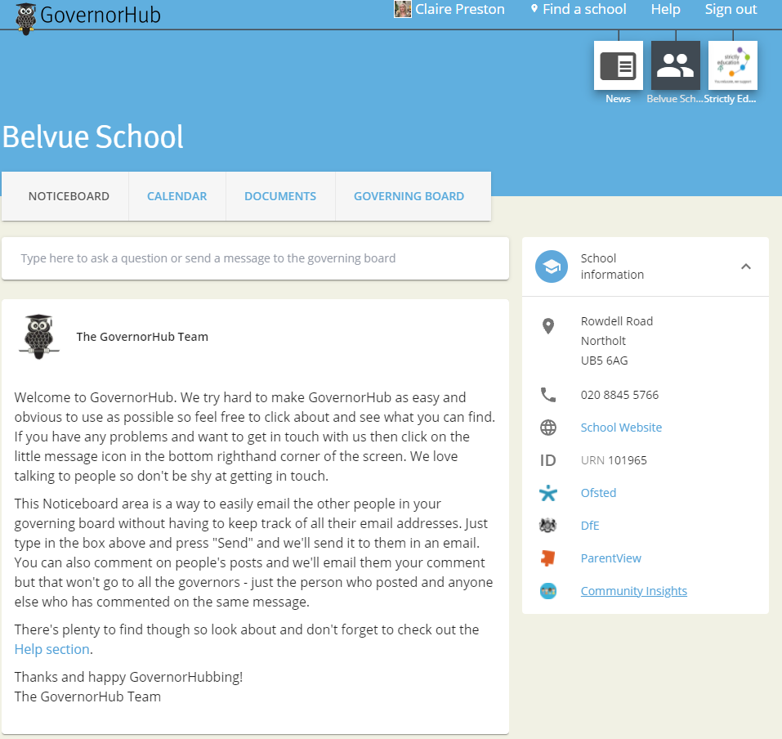
By clicking on the Community Insights link you will be able to explore a range of local contextual data amalgamated by the Governorhub team: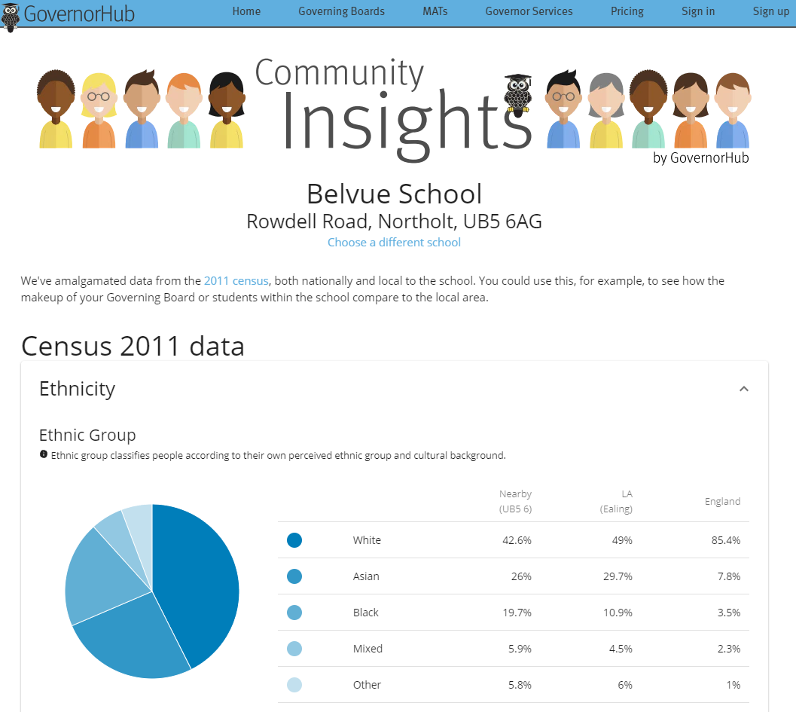

BELVUE SCHOOL – AUTUMN 2021
Here’s a quick snapshot of where our school is at the beginning of the Autumn 2021. Use this as a ready reference for our school’s key statistics.

Our pupils |  |  | School improvement priorities |  | Ofsted
Capacity: 210  Currently on roll: 212  % boys: 66.5%  % girls: 33.5%  % free school meals: 53%  % looked after: 2%  % previously looked after: 1%  % SEND: 100%  % EAL: 64%  % service: 0% |  |  | Standards of progress and attainment  Systems to keep community safe  Governors are strategic  Embedding assessment  Strengthen parental communication |  | Current grade: Good  Date of last inspection: 2016
 |  |  |  |  | ATTENDANCE 2020-21
 |  |  |  |  |  |  | OUR SCHOOL |  | NAT’L AVERAGE
 |  |  | BEHAVIOUR AND SAFEGUARDING |  | % ABSENCE |  | 10.4% |  | -
 |  |  | Academic Year 2020/21 number of:  Safeguarding incidents: tbc  Racist incidents: tbc  Bullying incidents: tbc  Fixed-term exclusions: 1  Permanent exclusions: 0 |  | % UNAUTHORISED |  | 2.8% |  | -
 |  |  |  |  | % PERSISTENT |  |  |  | -
 |  |  |  |  | STAFFING
 |  |  |  |  |  | TEACHING STAFF |  | SUPPORT STAFF
BUDGET |  |  |  |  | # STAFF | 33 |  | 48
 | 2019/20 |  | 2020/21 | 2021/22 (forecast) | # LONG TERM SICK | 2 |  | 0
INCOME | £4660838 |  | £4993737 | £5363267 | # MAT LEAVE | 0
EXPENDITURE | £4801387 |  | £4861495 | £5364434 | % MEN/  WOMEN | 25%/75%
IN-YEAR BALANCE | -£140549 |  | £132242 | -£1167 | GENDER PAY GAP | Reported by LA
PERFORMANCE DATA
PROGRESS |  | To be updated
ATTAINMENT |  | To be updated

Belvue Pupil SEN Needs Data

Pupil SEN Needs breakdown as of September 2021. This data only accounts for the pupils primary SEN need and not additional needs. Most pupils do have 2 or more SEN needs.

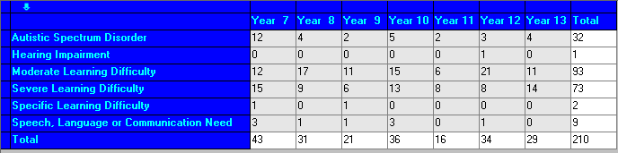
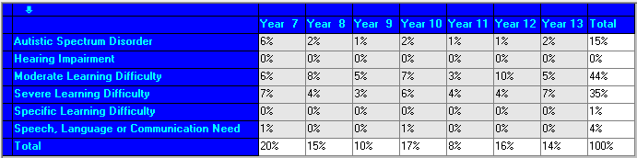

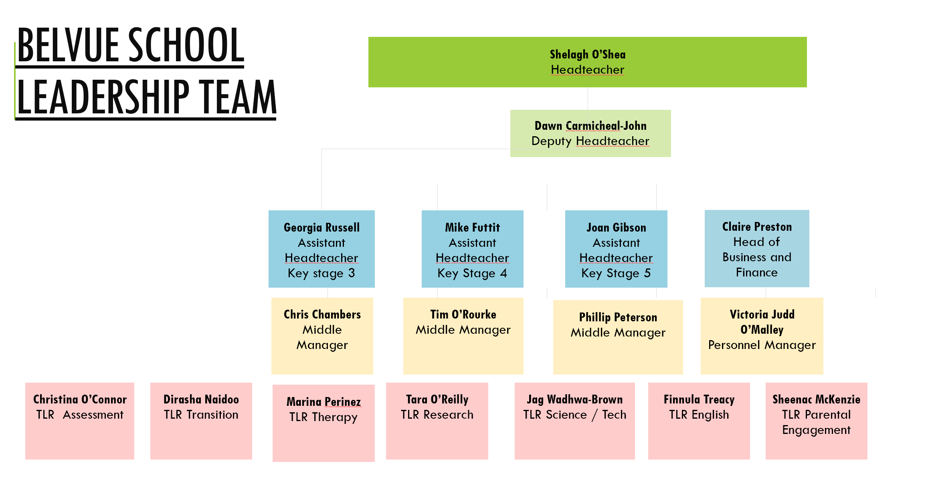

School Structure and Staff Team
There are 21 classgroups in September 2021 accommodating 210 pupils across Key stage 3, 4 and 5.

Key Stage | MLD Classes | SLD Classes | SLD+ Classes
3 | 3 groups with 1 teacher and 1 Teaching Assistant | 4 groups with 1 teacher and 2 TAs | 3 groups with 1 teacher and 3 TAs
4 | 2 groups with 1 teacher and 1 Teaching Assistant | 2 groups with 1 teacher and 2 TAs | 1 group with 1 teacher and 3 TAs
5 | 2 groups with 1 teacher and 1 Teaching Assistant | 4 groups with 1 teacher and 2 TAs | No groups with 3 TAs
Totals (39) | 7 TAs | 20 TAs | 12 TAs

TEACHING STAFF ROLES
Deputy Head (Teaching and Learning Leader) | Dawn Carmichael-John
Assistant Head Key Stage 3 | Georgia Russell
Assistant Head Key Stage 4 | Mike Futtit
Assistant Head Key Stage 5 | Joan Gibson
Middle Manager and SLD Leader | Chris Chambers
Middle Manager and Induction/Mentoring Leader | Tim O'Rourke
Middle Manager and Community Partnerships Leader | Phillip Peterson
Science and Technology Leader | Jagdeep Wadhwa-Brown
Therapies Leader | TBA – SOS for meantime
Transition Into Belvue / Inclusion | Dirasha Naidoo
Transition – Moving On | Joan Gibson
Maths Leader | Tim O'Rourke
English Leader | Finnula Tracey
Computing Leader | Jenny Vaughan
PE Leader & Assessment Leader | Christina O'Connor
Work Related Learning Leader | Marina Perianez
Woodlands Leader | Mike Baldwin
RE/Spirituality Leader | Sheenac McKenzie
Working Memory Leader | Mike Baldwin
Humanities Leader | Flora Petrakou
PSHE Co Lead | Jamilah Owusu
Relationship and Sex Education | Renata Korzun
EAL Leader | Chris Chambers
Music Leader | Chris Chambers
Art/PSHE | Amanda Heaney
Food Technology Leader | Ben Shipton
Drama Leader | Will Prophet
Design Technology Leader | TBA
Art Leader | Tabitha Neal
Unqualified Teacher | Abdi Elmi
Unqualified Teacher – Food Tech | Sarah Grimstone
Instructor – Horticulture | Joanna Robins
Instructor – Music | Hannah Hurst
Instructor - DT/work experience | Agi Grogzka-Hinkins
Instructor - Yoga | Beatrice Ferazzi
Unqualified Teacher/Extended Schools | Helen Seraphin-Mobbs

Specialist teaching and teaching support staff

The school has a wide range of specialist teachers and teaching support roles, including higher level teaching assistants. They are led and managed by Dawn Carmichael-John, Deputy Headteacher.

HLTA staff and specialisms
Pauline Lee | PE/Playground organiser/OT support
Sukhy Virdee | Duke of Edinburgh
Mark Squire | Behaviour

Specialist Teaching Assistants
Selina Devine | Communications champion
Alina Cucos | Specific Literacy Difficulties
TBC | Science Technician
Selina Devine | Literacy Interventions/Teaching Assistant
Hannah Churchward | PE / OT support
Jamie Beepath | Covid Interventions

3 x Part Time Teaching Assistants
Jackie Hennessey
Rosalie Franklin
Angela Melham

Multi-disciplinary Team

The school has a number of different therapists who provide valuable input and support to both the young people and the school team. Referrals are co-ordinated and monitored by Mike Baldwin. Videos and guidance from the therapy team for parents are available on the school website.

Multi Disciplinary Team
Occupational Therapist | Liz Allsop | 3 days
Speech and Language Therapist | Clare Woodhead | 1.5 days
Speech and Language Therapist | Victoria Garrott | 2 days
Senior Clinical Specialist Nurse | TBC
Educational Psychologist | Emma Hill | 1 day
Psychotherapist (RESPOND) | Shanice Richards | 2 days
Counsellor | Julia Dryburgh | 2 days
Music Therapist | Omar | 1 day
Family Workers | Denis O'Brien & Elizabeth Niles | Full time

Business and Administration Support Team

The teaching and learning of the school is also supported by an extremely busy business and administration team over the two sites.

School Business and Support Team
Head of Business, Finance and Operations | Claire Preston
HR Manager | Victoria Judd
Admin Manager | Louise Scarott
Reception | Cecilia Louisor
KS5 Admin/Reception | Priti Chudasama
Senior Finance Officer | Ahmed Ebrahim
Data, Exam and Assessment | TBC/Greg Head (1-2 days)
Premises Manager (Rowdell Road) | Dave Shaw
Premises Manager (Carr Road) | Dave Shaw
Assistant Premises Manager (AM) Belvue | David Mitchell
Assistant Premises Manager (PM) Ken | Lee Barton
Premises Apprentice | Zain Syed
IT Technician (TRUSOL) | Shaun Mabin (3 days Tues, Wed & Thurs)

