POST 16 NEWSLETTER – JULY 2020

COMING TO AN END
This year’s Post 16 end date was postponed for the first time, but is now finally nearly here.
We know that this has been a strange time for everyone and we hope that you all take care of yourselves and continue to keep safe and look after your wellbeing.
The summer break will be different for many of our young people, but please make the most of it.
For those students coming back in September we look forward to a new year with you and for our students who are leaving us we pray you have a wonderful future and that you will come back and visit us.

CALLS AND INFORMATION HOME
Calls home will now be to gain information about how things are and may look going forward. If your child is staying at Belvue College you will be receiving a letter and information about September.
Your child’s safety is our number one priority and Ms O’Shea is putting everything in place to assure that this continues to the high standard it has always been.

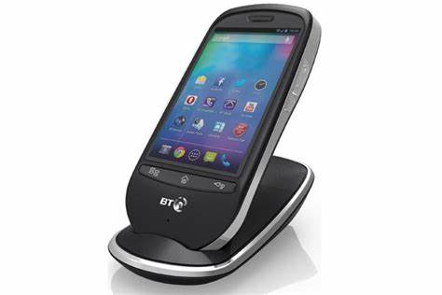

TRANSITION FROM BELVUE
If any student is leaving Belvue this year, please ensure that you have made contact with the relevant college or placement. Contact Adele Hines from Connexions for any additional support: 07710 104361. If you have not completed an application form and followed the process, you may not have a place for September.

LEAVERS GRADUATION
There will be a graduation for leavers ONLY (due to space) on Wednesday 22 July from 2:30pm at Belvue High School NOT the college.
You will have received a letter and phone calls regarding the number of people who you want to attend, your dietary needs, etc. If your child is leaving please support them in attending this special afternoon to remember your child’s life at Belvue.

IMPORTANT
Please use this number or email to let us know if there are any issues.

Ken Phone Number: 020 8422 0372
belvuecollege@belvue.ealing.sch.uk

ADVANCE NOTICE

Thursday 19th November – Transition Evening
Friday 11th December – Post 16 End of Term
Monday 14th – Friday 18th December – Post 16 Annual Reviews

