Belvue Careers Education, Information,

Advice and Guidance (CEIAG) Policy

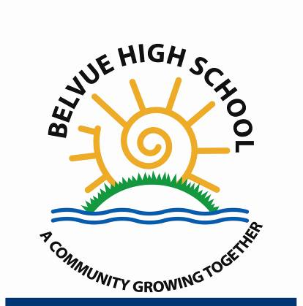

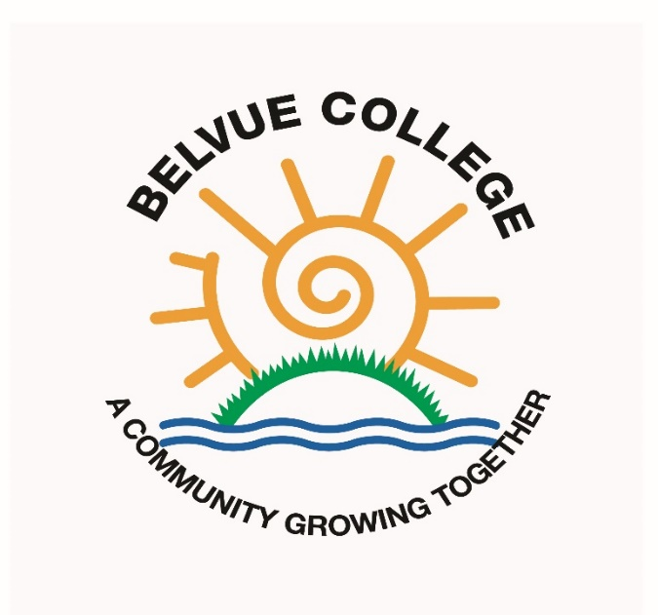

Contents

1.0 School Vision

2.0 Policy Scope

3.0 Objectives

4.0 School Responsibilities

5.0 Governor Responsibilities

6.0 Provider Access

7.0 Monitoring, Evaluation and Review

Appendix 1 Summary of the Gatsby Benchmarks
Appendix 2 Careers Charter
Appendix 3 Arrangements for Provider Access

Linked policies

WRL
PSHE
Work Experience

Linked Documents

‘Careers Guidance and access for education and training providers. Statutory guidance for governing bodies, school leaders and school staff’. DFE, January 2018
KS3/4 overview with Gatsby
Post 16 Overview with Gatsby

Adopted by the Governing Body: 30.03.2021
Compliance Check: 30.03.2021
Reviewed and updated: July 2021
Next Review Date: July 2022

Belvue Careers Education, Information,

Advice and Guidance (CEIAG) Policy

1.0 School Vision

1.1 Belvue seeks to maximise the life chances of all of our young people and so it is crucial to prepare young people for life beyond school and college. The values and principals document makes direct reference to developing:

‘Knowledge, skills and attributes they (Belvue students) need to lead successful and happy lives’.

1.2 The governing body have therefore adopted this policy in order to provide a clear commitment to and framework for Careers Education, Information, Advice and Guidance.

We want all the young people in Belvue school to have meaningful experiences that are appropriate for their ability level related to their pathway to adulthood and more specifically to their future in working and employment, whichever form this has. They will apply their own understanding of their qualities and skills to the ones needed for different jobs and careers in their closer and wider community. We want our pupils to become critic and curious individuals that are able to realistically look into their future and opportunities for adulthood and employment. As a school community we will support our pupils to build on their understanding and confidence gained through exploration and practical work in school and local areas.

1.3 At Belvue our vision is: “To be the centre of excellence for students with special educational needs."

2.0 Policy Scope

2.1 This policy covers Work Related Learning and Careers Education, Information, Advice and Guidance given to students in Key Stages Three, Four and Five.

Belvue school is committed to maximising the benefits for every pupil, in the development of a whole school approach to careers and work-related learning. The school recognises that there should be some work-related learning for all pupils, and more for some. The school wishes to promote work-related learning and Careers as part of the learning entitlement for all pupils and as a means for learning ‘about work’, learning ‘through work’ and learning ‘for work’

2.2 The policy also applies to Year 11 and Post 16 students after they finish their examinations in June of their final year and before they either start our Post 16 or their next place of education or an internship. Though not necessarily in school regularly and attending lessons in July and august, the policy is still applicable.

There is a statutory requirement under Section 351 of the 1996 Education Act for the school to provide a balanced and broadly based curriculum which ‘ prepares pupils for the opportunities, responsibilities and experiences of adult life, which includes preparation for working life.

2.3 The policy has been reviewed in line with the recently published DfE guidance document ‘Careers guidance and access for education and training providers – Statutory guidance for governing bodies, school leaders and school staff. (DfE, January 2018)

2.4 This policy accepts the 8 Gatsby Charitable Foundation’s benchmarks as set out in the DfE guidance. They can be seen in Appendix 1 of this policy.

2.5 This policy covers the legal duty of schools to ensure that a range of education and training providers can access pupils in Year 7 to Year 14 for the purpose of informing them about approved technical education qualifications or apprenticeships.

2.6 This policy refers to events and opportunities in all three Key Stages and in all years and these events will impact upon all students at the school.

2.7 All members of staff at Belvue are expected to be aware of this policy and the importance of Work Related Learning and Careers Education, Information, Advice and Guidance (CEIAG) in the education of students; CEIAG is not the sole responsibility of the Careers Advisor.

2.8 It is important therefore that students leave Belvue aware of themselves as individuals, aware of the opportunities available to them and able to make some decisions about their own life. They should be prepared for the transition from full time education to the world beyond. It is to these aspects of personal and social development that this policy will contribute.

3.0 Objectives:

3.1 The objectives of the Work Related Learning and Careers Education, Information, Advice and Guidance policy are as follows:

3.1.1 To ensure that all students at the school receive a stable careers programme

3.1.2 To enable all students to learn from information provided by the career and labour market

3.1.3 The CEIAG programme should be individual and address the needs of each student

3.1.4 To link the curriculum learning to careers learning

3.1.5 To provide students with a series of encounters with employers and employees

3.1.6 To provide students with experiences of workplace(s)

3.1.7 To ensure that students have a series of encounters with further education

3.1.8 To provide each student with the opportunity to receive personal guidance

4.0 School Responsibilities

4.1 The school has a series of statutory duties:

4.1.1 to raise levels of attainment through high quality work-related learning for all pupils;

    - to develop a range of opportunities which enhance the curriculum;

    - to promote greater awareness for pupils about the world of work, the development of key skills and employability;

    - to develop a range of appropriate and relevant activities which assist in raising all pupils’ aspirations and achievement and which are of the highest possible quality and are regularly monitored;

    - to promote awareness and understanding of work, industry, the economy and community;

    - to relate skills attitudes, concepts and knowledge learned in school to applications in the wider world;

    - to develop pupils’ personal and social skills in relationships in a range of contexts;

    - to provide pupils with informed and impartial guidance on the choices available for education, training and employment as well as other interests;

    - to improve employability through work-related learning and Careers

    - to develop effective links with key partners which include Talentino, Connexions, Dynamic Training, NHS Trust, and many others.

4.1.11 All registered pupils at the school must receive independent careers advice in Years 7
to 14

4.1.12 This careers advice must be represented in an impartial manner, showing no bias towards a particular institution, education or work option

4.1.13 This advice must cover a range of education or training options

4.1.14 This guidance must be in the best interests of the pupil

4.1.15 There must be an opportunity for education and training providers to access pupils in Year 7 – Year 14 in order to inform them about approved qualifications or internships. Cf. Section 6 of this policy

4.1.16 The school must have a clear policy setting out the manner in which providers will be given access to pupils. Cf. Section 6 and Appendix 3. This policy and these arrangements must be published

4.2 The school will base its careers provision around the Gatsby Benchmarks. A summary of these can be seen in Appendix 1, and they cross reference with the objectives of this policy cf. Section 3

4.3 Belvue believes that good WRL and CEIAG connects learning to the future. It motivates young people by giving them a clearer idea of the routes to jobs and careers that they will find engaging and rewarding. Good CEIAG widens pupils’ horizons, challenges stereotypes and raises aspirations. It provides pupils with the knowledge and skills necessary to make successful transitions to the next stage of their life. This supports social mobility by improving opportunities for all young people, especially those from disadvantaged backgrounds and those with special educational needs and disabilities.

4.4 The school will continuously monitor its WRL and CEIAG offer and seek further improvement. This will be done by the personnel involved in the design and delivery of the programme as well as by external stakeholders who assess the work of the school (e.g. School Improvement Partner or Ofsted)

5.0 Governor Responsibilities

5.1 The governing body will ensure that the School has a clear policy on Careers Education, Information and Guidance (CEIAG) and that this is clearly communicated to all stakeholders. They should ensure that this policy is:

5.1.1 based on the eight Gatsby Benchmarks

5.1.2 meeting the school’s legal requirements

5.2 The governing body will ensure that arrangements are in place to allow a range of educational and training providers to access pupils in Years 7 – 14.

5.3 There will be a member of the governing body who takes a strategic interest in CEIAG and encourages employer engagement

6.0 Provider Access

6.1 Introduction - This section of the policy sets out the school’s arrangements for managing the access of providers to pupils at the school for the purpose of giving them information about the provider’s education or training offer. This complies with the school’s legal obligations under Section 42B of the Education Act 1997.

6.2 All pupils in years 7-14 are entitled:

6.2.1 to find out about technical education qualifications and apprenticeships opportunities, as part of a careers programme which provides information on the full range of education and training options available at each transition point;

6.2.2 to hear from a range of local providers about the opportunities they offer, including technical education and apprenticeships – through options events, assemblies and group discussions and taster events;

6.2.3 to understand how to make applications for the full range of academic and technical courses.

6.3 Appendix 3 shows the way in which education and training providers should get in touch with the school in order to gain access to pupils and/or parents to inform them about further opportunities

6.4 The school will then work with providers in order to identify the most effective opportunity for them to share information about education and training opportunities

7.0 Monitoring, Evaluation and Review

7.1 The Headteacher will ensure that:

7.1.1 the work of the Careers Advisor and CEIAG events are supported and monitored

7.1.2 a member of the Senior Leadership Team has an overview of CEIAG work and reports regularly back to the team

7.2 The effectiveness of this policy will be measured in a variety of ways:

7.2.1 Feedback from our stakeholders;

7.2.2 Feedback from external visitors to the school such as the School Improvement Partner (SIP) or Ofsted;

7.2.3 The number of students who are NEET in October having left the school in the
previous summer. This figure can be compared to national figures as well as against
the equivalent figure from similar schools both nationally and within the county.

7.3 Termly update of the Careers Enterprise Company Compass Evaluation tool.

7.4 Annual update of the Talentino Careers Health check list.

7.5 The Governors of Belvue will review this policy every three years.

The Gatsby Benchmarks Appendix 1

1. A stable careers programme | Every school and college should have an embedded programme of career education and guidance that is known and understood by students, parents, teachers, governors and employers. | - Every school should have a stable, structured careers programme that has the explicit backing of the senior management team, and has an identified and appropriately trained person responsible for it.  - The careers programme should be published on the school’s website in a way that enables pupils, parents, teachers and employers to access and understand it.  - The programme should be regularly evaluated with feedback from pupils, parents, teachers and employers as part of the evaluation process.
2.Learning from career and labour market information | Every student, and their parents, should have access to good quality information about future study options and labour market opportunities. They will need the support of an informed adviser to make best use of available information. | - By the age of 14, all pupils should have accessed and used information about career paths and the labour market to inform their own decisions on study options.  - Parents should be encouraged to access and use information about labour markets and future study options to inform their support to their children.
3.Addressing the needs of each student | Students have different career guidance needs at different stages. Opportunities for advice and support need to be tailored to the needs of each student. A school’s careers programme should embed equality and diversity considerations throughout. | - A school’s careers programme should actively seek to challenge stereotypical thinking and raise aspirations.  - Schools should keep systematic records of the individual advice given to each pupil, and subsequent agreed decisions.  - All pupils should have access to these records to support their career development.  - Schools should collect and maintain accurate data for each pupil on their education, training or employment destinations.
4.Linking curriculum learning to careers | All teachers should link curriculum learning with careers. STEM subject teachers should highlight the relevance of STEM subjects for a wide range of future career paths. | - By the age of 14, every pupil should have had the opportunity to learn how the different STEM subjects help people to gain entry to, and be more effective workers within, a wide range of careers.
5.Encounters with employers and employees | Every student should have multiple opportunities to learn from employers about work, employment and the skills that are valued in the workplace. This can be through a range of enrichment activities including visiting speakers, mentoring and enterprise schemes. | - Every year, from the age of 11, pupils should participate in at least one meaningful encounter* with an employer.  *A ‘meaningful encounter’ is one in which the student has an opportunity to learn about what work is like or what it takes to be successful in the workplace.
6.Experiences of workplaces | Every student should have first-hand experiences of the workplace through work visits, work shadowing and/or work experience to help their exploration of career opportunities, and expand their networks. | - By the age of 16, every pupil should have had at least one experience of a workplace, additional to any part-time jobs they may have.  - By the age of 18, every pupil should have had one further such experience, additional to any part-time jobs they may have.
7.Encounters with further and higher education | All students should understand the full range of learning opportunities that are available to them. This includes both academic and vocational routes and learning in schools, colleges, universities and in the workplace. | - By the age of 16, every pupil should have had a meaningful encounter* with providers of the full range of learning opportunities, including Sixth Forms, colleges, universities and apprenticeship providers. This should include the opportunity to meet both staff and pupils.  - By the age of 18, all pupils who are considering applying for university should have had at least two visits to universities to meet staff and pupils.  - *A ‘meaningful encounter’ is one in which the student has an opportunity to explore what it is like to learn in that environment.
8.Personal guidance | Every student should have opportunities for guidance interviews with a career adviser, who could be internal (a member of school staff) or external, provided they are trained to an appropriate level. These should be available whenever significant study or career choices are being made. | - Every pupil should have at least one such interview by the age of 16, and the opportunity for a further interview by the age of 18.

Belvue Careers Charter Appendix 2

The school offers a wide range of activities that contribute towards work-related and Careers opportunities in order to help prepare pupils effectively for adult and working life, as well as continuing to work within the framework of the pathways to adulthood, depending on their individual needs and strengths. These activities complement subject teaching, contribute towards the development of pupils’ key skills as well as contributing to lifelong learning opportunities.

The range of activities the school is currently using in order to help meet its objectives include but it is not limited to:
- Vocational courses
- Careers Education and Guidance
- Work Experience
- Work shadowing
- Visits to employers
- Visits by employers
- Enterprise projects
- Personal and Social Education

Key Stage 3 – Year 7, 8, 9
The Work Related Learning curriculum, that includes basic careers education, is delivered to KS3 pupils on a weekly basis. Pupils will learn about different jobs and work places in their community. They will identify their personal details, skills, review their targets and find out who can help them in their community.
Work experience encounters may include visits from the Police, Firefighters and the opportunity to discover work places such as Heathrow Farm.

Key Stage 4 – Year 10, 11
The Careers programme at KS4 is delivered on a weekly basis. Pupils will learn about the key skills for different jobs and identify what jobs they may aspire to do in the future. They will identify their own skills; how to write a CV and identify job roles in different sectors.
Pupils will have the opportunity to complete a week’s Horticulture or Catering work experience at Green Corridor. Other work experience encounters and visits pupils may have the opportunity to take part in include the Police, Fire Service, Asda, Sky, McDonalds and more arranged through the Careers Enterprise Programme.

Key Stage 5 – Year 12, 13, 14
As well as the Post 16 Curriculum, which covers Pathways to Adulthood, Post 16 pupils follow OCR Life and Living units and the Princes Trust Achieve Programme.
Pupils working at Entry level 1 and 2 complete a range of units, which goes towards different qualifictaions e.g. an Introductory Award, Award, Extended Award or Certificate. Topics can range from Following Instructions, to Working as Part of a Group and Completing an Enterprise Activity.
Pupils working at Entry level 3 and level 1 complete a range of units, which go towards a Princes Trust Achieve qualification. Units include topics such as Teamwork, Work Experience and Careers.
Pupils in Post 16 take part in regular work experience e.g. at the Litten Nature Reserve, the Ealing NHS Trust, Welshore Hub and Havelock. They also have an annual Employability Week and visits arranged through the Careers Enterprise Programme and previously Clusters. These include the Police, Travelodge, Sainsburys, Army Reserve, Clementina Day Centre and Crowne Plaza hotel.
Pupils also get the opportunity to take part in a Taster Day at a Further Education college and visit the Supported Internship Fair at Hammersmith and Fulham College and other organised events throughout the year.

Application for Provider Access Appendix 3

Introduction

This document sets out the school’s arrangements for managing the access of providers to pupils at the school for the purpose of giving them information about the provider’s education or training offer. This complies with the school’s legal obligations under Section 42B of the Education Act 1997.

Pupil entitlement

All pupils in years 7-14 are entitled:
- to find out about education qualifications and internship opportunities, as part of a careers programme which provides information on the full range of education and training options available at each transition point;
- to hear from a range of local providers about the opportunities they offer, including internships – through options events, assemblies and group discussions and taster events;
- to understand how to make applications for the full range of academic courses.

Management of provider access requests

Procedure
A provider wishing to request access should contact:

Key Stage 3 / 4 | Key Stage 5 / Post 16
Name: Marina Perianez  Telephone: 020 8845 5766  Email: marinap@belvue.ealing.sch.uk | Name: Phillip Peterson  Telephone: 020 8422 0372  Email: phillipp@belvue.ealing.sch.uk

Opportunities for access

The school offers a comprehensive Careers Education, Information, Advice and Guidance programme and an overview of this programme can be seen in the School’s Careers Charter which can be seen on the school website.

Please speak to our Careers Advisor to identify the most suitable opportunity for you.

The school will make a suitable space available for discussions between the provider and students, as appropriate to the activity. The school will also make available ICT and other specialist equipment to support provider presentations. This will all be discussed and agreed in advance of the visit with the Careers Advisor or a member of their team.

Providers are welcome to leave a copy of their prospectus or other relevant course literature with the Careers Advisor so that they can be displayed in the school library and at the college.

