Now here’s a chance for you all to show your true colours, your favourite football team is playing their biggest rivals in the cup final. For this task, you will need to produce a poster to advertise the match. First, use the internet to research football posters for some ideas. Then use Powerpoint to create your poster and the internet to find images for the poster. Email your teacher completed posters.
You must include
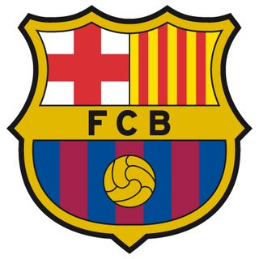
- Your teams name and badge

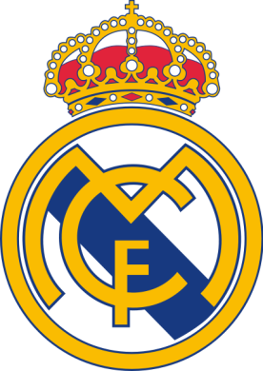

- The other teams name and badge

- The date of the fixture.
- The price of the tickets.
- An image of the ground where the fixture is to be played.
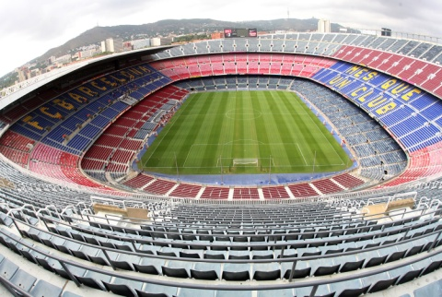

- Pictures of current players or managers from both teams.

- The score and date of the last fixture played by these teams.

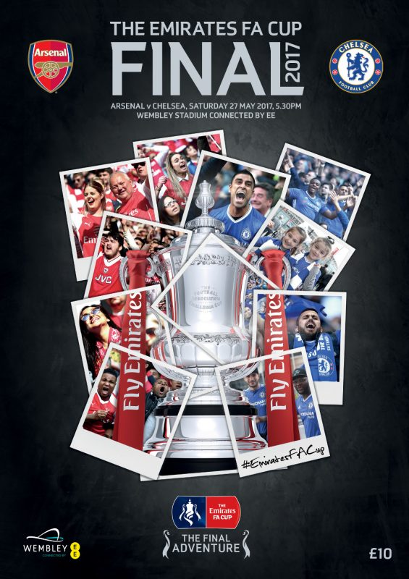
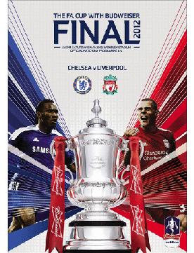
Here are some examples of posters

