POST 16 NEWSLETTER – SEPTEMBER 2020

WELCOME
A very warm welcome, to our students at the start of this new academic year.
New procedures have been put in place due to Covid (refer to the school website), to ensure the safety and wellbeing of everyone while at the college.

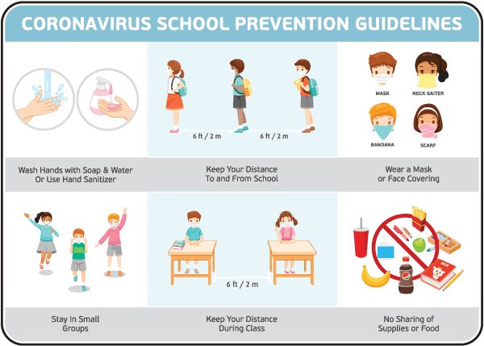

As is the custom, many students coming into Year 13/14 have changed classes to accommodate a young person’s academic ability, emotional needs, level of independence and social skills.
The team continue to be excited about an inspiring new curriculum that we created for Post 16 last year and are eager to convey it to our students.
We are hoping for a refreshing and stimulating new year.

The Post 16 Team are:
5FP – Mrs Petrakou florap@belvue.ealing.sch.uk & Mrs Craven
5BS – Mr Shipton bens@belvue.ealing.sch.uk & Miss Messit
5JG – Miss Gibson (Assistant Head) joang@belvue.ealing.sch.uk & Miss Obado
5AH – Ms Heaney amandah@belvue.ealing.sch.uk & Mrs Spry
5LB – Mrs Buchan lisab@belvue.ealing.sch.uk & Mrs Kingcharoen
5PP - Mr Peterson (Deputy Head) phillipp@belvue.ealing.sch.uk & Ms Stapleton
1:1s – Miss Khan & Mr Johnson

Ken Phone Number: 020 8422 0372
belvuecollege@belvue.ealing.sch.uk
Please use this number or email let us know if your child is running late, is ill, if they have an appointment or for any other reason.

In addition, can you please ensure that the college has your correct mobile number, the number of a second person in case of an emergency and email address, as communication between home and college will take place via these methods; student diaries will not be going home.

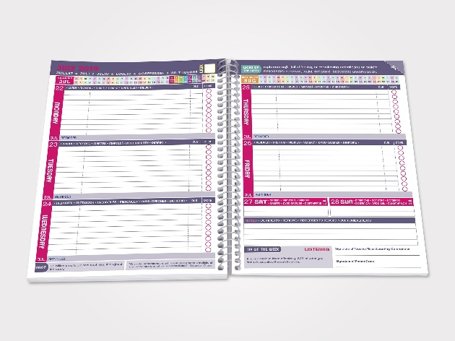

COLLEGE TIMES
College starts at 8:45 and finishes at 3:00 daily. Break is at 10:45-11:00 and lunch is in two sittings from 12:30-1:30.

COLLEGE DRESS CODE AND WORK UNIFORMS
Your child is expected to come to college dressed accordingly and appropriately.
In addition, your child will be given a work uniform which he/she is expected to wear on allocated days related to their timetable. Please also ensure that your child is wearing the correct footwear e.g. boots with their work uniform.

FREEDOM PASSES / OYSTER ZIP CARDS AND BUS TRAVEL
Please ensure that your child has an up-to-date Freedom Pass or Oyster Zip Card for the new academic term 2020/21. It is important that your child brings their card into college every day, even if they are non-independent.
Remember there are special buses for students to use and your child is to look out for those.

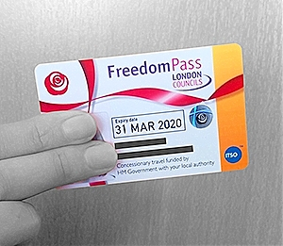
TRAVEL TRAINING
Ealing Mencap travel training project now comes under Hounslow Travel Training.
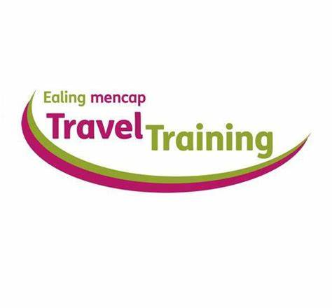
For more informtion and help contact:

Website: www.ealingmencap.org.uk
Phone: 020 8566 9575
Email: travel.training@ealingmencap.org.uk

TIMETABLE REQUIREMENTS

Subject | Day / Meet at | Lunch | Kit
Computing: Belvue School 5JG | Monday-The Venue | Packed lunch | N/A
Community 5LB | Tuesday-Ken | Packed lunch | Work uniform
Enrichment / Environment 5BS | Friday-Ken | Packed lunch | Work uniform
Hospitality and Catering:  Southall College 5PP | Thursday-Direct to College | Packed lunch or as advised | Kitchen whites
Litten 5AH, | Monday-Ken | Packed lunch | Work uniform
Litten 5FP, | Tuesday-Ken | Packed lunch | Work uniform
NHS 5PP | Tuesday-The Venue | Packed lunch | Work uniform
Retail: Southall College 5AH | Friday-Ken | Packed lunch | Work uniform
Welshore Hub  Shop 5JG | Wednesday-Ken or Direct to shop | Packed lunch or money for food | Work uniform

All other times your child can have a school lunch £2 or bring in a packed lunch.
The college meals are all vegetarian with an occasional fish/meat dish during the year. If your child is free school meals their lunch will be provided.

Please call for more information if unsure about anything.

*IMPORTANT ADVANCE INFORMATION*

COLLEGE CLOSED
Thursday 22nd October Training Day – School Closed
Friday 23rd October Occasional Day – School Closed
​Monday 26th – Friday 30th October Half Term
Monday 2nd November Occasional Day – School Closed

THURSDAY 19 NOVEMBER
Transition Evening – this is an opportunity to obtain information regarding your child’s future after Post 16 by hearing from different organisations, including colleges, Mencap, NCS The Challenge and Connexions.
The format of this meeting may have to change due to Covid, but we will inform you nearer the time of how that may look.

FRIDAY 11 DECEMBER
END OF TERM – last day of term for all Post 16s. This is a normal school day finishing at 3:00pm.

MONDAY 14 – FRIDAY 18 DECEMBER
ANNUAL REVIEWS – If there are any days, dates or times during that week that you cannot do, can you let the college office know by the Friday 2nd October as your invitation slot will to be sent out by the end of October.
The format of these meetings may have to change due to Covid, but we will inform you nearer the time regarding how that may look.

