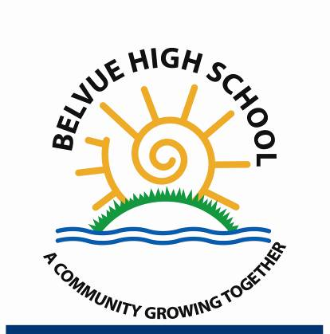
Careers Programme

Key Stage 3 – Year 7, 8, 9
The Work Related Learning curriculum, that includes basic careers education, is delivered to KS3 pupils on a weekly basis. Pupils will learn about different jobs and work places in their community. They will identify their personal details, skills, review their targets and find out who can help them in their community.
Work experience encounters may include visits from the Police, Firefighters and the opportunity to discover work places such as Heathrow Farm.

Key Stage 4 – Year 10, 11
The Careers programme at KS4 is delivered on a weekly basis. Pupils will learn about the key skills for different jobs and identify what jobs they may aspire to do in the future. They will identify their own skills; how to write a CV and identify job roles in different sectors.
Some key stage 4 students will complete units, which will go towards an Edexcel Workskills qualification.
Pupils will have the opportunity to complete a weeks Horticulture or Catering work experience at Green Corridor. Other work experience encounters and visits pupils may have the opportunity to take part in include the Police, Fire Service, Asda, Sky, McDonalds and more arranged through the Careers Enterprise Programme.

Key Stage 5 – Year 12, 13, 14
Post 16 pupils follow the Edexcel Workskills and Princes Trust curriculum.
Pupils working at Entry level 1 and 2 complete a range of units, which will go towards an Edexcel Workskills qualification. Topics can range from Following Instructions, to Working as Part of a Group and Completing an Enterprise Activity.
Pupils working at Entry level 3 and level 1 complete a range of units, which go towards a Princes Trust Achieve qualification. Units include topics such as Teamwork, Customer Service and Managing Money.
Pupils in post 16 take part in regular work experience at the NHS, Hanwell Zoo, the Litten, Welshore Hub, Havelock and Horsenden Hill. They have further opportunities to visit work places, and encounter a range of employers during Employability Week and visits arranged through the Careers Enterprise Programme and previously Clusters. These include the Police, Travelodge, Sainsburys, Army Reserve, Clementina Day Centre and Crowne Plaza hotel.
Pupils also get the opportunity to take part in a Taster Day at a Further Education college and visit the Supported Internship Fair at Hammersmith and Fulham College.

Reviewed and Updated: July 2021
Next Review Date: July 2022

