POST 16 NEWSLETTER – JULY 2021

LEARNING CONVERSATIONS
During this final half term, your child’s teacher will be making contact with you in order to make arrangement for your final learning/transition conversation. This will take place via zoom or a phone call. These are important meetings so please ensure you make any appointment set.

LAST TWO WEEKS OF TERM
Now that the end of year date for Post 16s has been extended, until Friday 16 July, students will have the opportunity to undertake a number of enriching activities for two weeks with their peers. Please see the timetable below of the events happening during these two weeks (subject to change).

Post 16 Enrichment Timetable – Monday 5 – Friday 16 July
Week 1
 | 5FP | 5BS | 5JG | 5AH | 5LB | 5PP
Monday 5 | Shopping | Bunny Park | Digital Skills | Shopping | Normal day | Cooking
Tuesday 6 | Litten | Shopping | Shopping | Afternoon Tea | Havelock | Shopping
Wednesday 7  School council | Creative Cooking | Greenford Quays | Art | Swimming | shopping | Cinema
Thursday 8 | Art | Art | Greenford Quays | Speeches | Speeches | Speeches
 | BBQ / DISCO PM
Friday 9 | SPORTS DAY

IMPORTANT NOTICE: SHOPPING TRIP – Amount given to students has had to be adjusted.

Week 2
 | 5FP | 5BS | 5JG | 5AH | 5LB | 5PP
Monday 12 | Craft | Craft | Digital Skills | Socialisation | Art | Greenford Quays
Tuesday 13 | SEASIDE – Littlehampton
Wednesday 14 | Games | Games | Art | Reflection | Reflection | KEW
 | CINEMA/FILM DAY
Thursday 15 | Local Trip | Local Trip | Walk | Leaving Stuff | Leaving stuff | Leaving Stuff
 | GRADUATION – AFTER COLLEGE
Friday 16 | SOCIALISATION / CLEAR UP / LEAVERS T-SHIRT SIGNING DAY

LEAVERS GRADUATION
We will be having a socially distanced leaver’s graduation on Thursday 15 July. The event will take place for leavers and their family only at the main site where there is more space to be socially distanced and grouped as a family. If your child is leaving please ensure that you attend to support them during this important transition. More information will be made available nearer the time in a letter.

LEAVERS PROM
The Leavers Prom will be on Tuesday 20 July. The venue has had to move to the college due to government guidelines. However, we will ensure that the event is a huge success and a wonderful evening that all of our leavers will remember. Once your child has paid for the Prom in full, they will receive their ticket.

CORONAVIRUS TESTING
If you are undertaking weekly rapid tests of your child, please make a note in their diary of the result – as simple as an X if negative. Call the college to inform us if the result is positive and keep your child at home and follow government guidance.
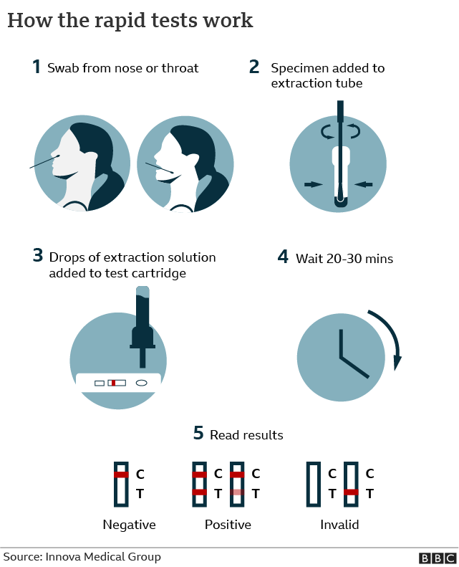

SMASHING GLASS
REMINDER: Belvue’s Glass Enterprise will be selling their products through the college. There is a mixture of jewellery (e.g. pendants/necklaces, earrings and broches) and items for the home (e.g. decorations, mirrors, coasters, small bowls) that you can buy. Prices range from £4 - £15. Please let us know if you are interested in purchasing anything. There is always a festival or celebration around the corner and it is an ideal time to buy something for a loved one or friend.

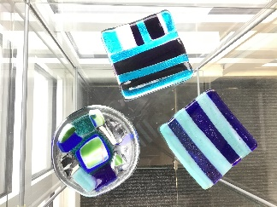 | 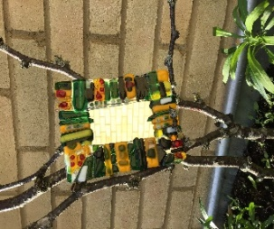 | 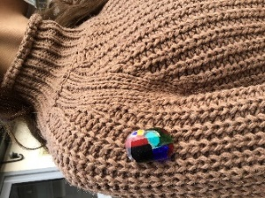 | 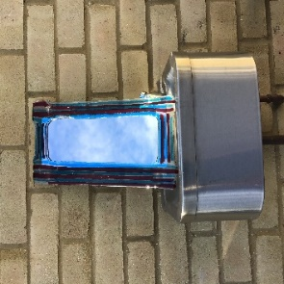

CONTACTING STAFF
If you have any concerns regarding anything while your child is at the college please contact us to book an appointment or to speak to someone on: 020 8422 0372

*ADVANCE NOTICE 2021*

Thursday 15 July – Leavers’ Graduation (at main site Rowdell Road)

Monday 5 – Friday 16 July – Fun Enrichment Activities

Friday 16 July – End of Year

Tuesday 20 July – Leavers’ Prom

Monday 13 September – Start of New Academic Year

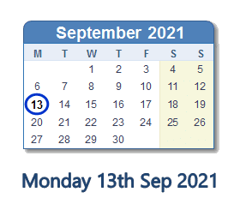

The Post 16 Team wants to wish all our students and families an amazing summer break!
For those of you who are leaving us and starting a new adventure, we pray you are successful in everything you do!
We will miss you, but it is your time.

