POST 16 NEWSLETTER – JUNE 2022

LAST DAY OF TERM
The year has gone by so quickly and FRIDAY 24 JUNE is the last day of term. College will finish at 3:00pm. If your child is staying at Belvue for another year, then we look forward to seeing them on Monday 12 September at the main Belvue site on Rowdell Road. If your child is a leaver please provide them with a large bag during the last week as they will have things they may want to take home with them.

EALING TRANSITION EVENT
This is an online event on Wednesday 8 June, 1:00-2:00pm. From the age of 14, young people, parents, carers, and families are supported by a dedicated team to coordinate services for the young preparing to move towards adulthood. The team will support young people to be aspirational about their future; as well as working closely with other agencies involved to make the transition in adulthood a positive and seamless journey. The Transitions Team will provide advice, information, assessment, support planning, case coordination and will review services to young people with a disability aged 14 to 18 transitioning into adulthood.
RESIDENTIAL
After what felt like an extremely long time, the annual Post 16 residential was finally able to take place and it was a huge success! All students and staff had an amazing experience. The week was filled with time spent together and students enjoying spending time with their friends and doing a range of different activities. The venue had a beach on site, a fun swimming pool with slides, a club house with daily evening activities including a number of different shows, bingo and a disco, there was a fun fair, bowling, shops, arcade and games, and a variety of food to choose from with us either eating out in restaurants, on the beach or in the caravan.

SPORTS DAY
Monday 20 June is our sport’s day. Your child will need to have their Oyster Card/Freedom Pass, be dressed in sportswear and have a packed lunch and any snacks. If your child is on school transport, they will be met by staff at the main site and taken to the venue on public transport or minibus and returned to the main site at the end of the day. If you usually drop your child at college, we will ask you to drop them at the venue (Rectory Park). If your child is independent they can either meet at the venue or meet staff in Northolt at the bus stop. You will receive another letter nearer the time with more information and your response regarding your child’s arrangement for the day.

COLLEGE VISITS
There will be another college visit for the leavers during the week beginning Monday 13 June. The colleges have only arranged visits for Southall or Ealing Green. Students, accompanied by staff, will visit the college they had requested and have had interviews for.
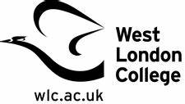

LEAVERS GRADUATION
Wednesday 22 June @ 5-6:30pm. If your child is a leaver please ensure that you keep this significant day in your diary. It will be a memorable evening for leavers to say goodbye to Belvue and to share their memories of their life with us. Leavers will have the opportunity to see images of themselves from when they first started at Belvue until now. There will also be light snacks and drinks and time to say goodbye to friends and staff. Please complete the letter so we know how many people to cater for.

END OF TERM BBQ
Students will be having their end of year BBQ and disco at the college on the last day of term (Friday 24 June). It’s a time to say goodbye to friends and staff before breaking up for the summer. However, we do hope that you allow your child to exchange numbers with their friends to stay in contact with them over the holidays or you support your child to do so, if they cannot do it themselves, by contacting parents of their friends in order to facilitate this.

PROM
Thursday 30 June is the date for this year’s Prom. This is a wonderful time for students to dress to impress and have an evening of fun, food and dancing with their friends. The cost of the evening will be £15. This will include an amazing range of things for your child’s entertainment: pre-drinks and snacks, celebratory photos, an evening meal, drinks, disco and goody bag. Please ensure that you have sent your letter back so that we know numbers.

BENEFIT LETTER
This is the time when the benefit office will be contacting certain families regarding what their child will be doing or where they will be going (e.g. which placement) in September 2022. Some letters will say that your child’s benefit will be stopping on September 5th. Please do not worry. After the holidays, we will have letters available for you to send off with your forms or we will help you to complete your form if you require. Just contact us to let us know.

FREEDOM PASS/OYSTER CARD
Please check and ensure that your child has a valid up-to-date Freedom Pass or Student Oyster Card 16+ or 18+, whichever applies at the time. All students need to have one for the beginning of the new academic year starting in September for Belvue, and for any leavers, for the new placement they will be transitioning onto.
If you need support with completing any of the forms let us know.

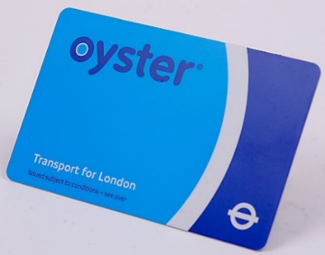

*IMPORTANT ADVANCE INFORMATION*

Monday 12 September Start of Term
Monday 24 – Friday 28 October Half Term
Monday 31 October Occasional Day/Closed

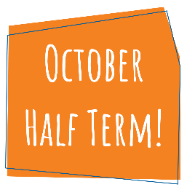

APPOINTMENTS
If you would like to see your child’s VT/class teacher or Miss Gibson please write a note in your child’s diary or call the college office to book an appointment.
Ken Phone Number: 020 8422 0372 / Belvue Phone Number: 020 8845 5766
belvuecollege@belvue.ealing.sch.uk

