POST 16 NEWSLETTER – FEBRUARY 2021

GREETINGS
Welcome to another month of remote learning. Hopefully by now you and your child will have mastered how to access Google classroom, Myon and their email to send and receive messages from the teacher /TA.

GOOGLE CLASSROOM
Work will be delivered through G-Suite (Google Classroom) and new work will be uploaded each week. All students who are at home are expected to undertake their work. If you or your child has any issues with accessing their work online email edtech@belvue.ealing.sch.uk for support.
Let us know if you do not have your child’s login information.

PHONE CALLS
There will be weekly phone calls to families of students who are not accessing the online lessons. As you now know the call may come from a private number so please answer. We will want to speak the student each time.
Use these calls as an opportunity to tell staff of any issues and concerns your child (or yourselves) may be having.

ANNUAL REVIEWS
The majority of annual reviews have taken place; however, if your child has not had theirs, please ensure that you let the class teacher know your availability to hold the review over the phone / Zoom as soon as possible. Your child will need to be present at all times. If your child will be leaving this year then it is even more important that this happens in order for a consultation to be made for the transition to their next setting.

TRANSITION EVENING
We will be having a Transition Evening on Thursday 25 February. It will be held online in the evening, so you will be able to access it from home. A letter / text will be sent out before the event. Please think of any questions you would like to ask and email them to the office before the event.

SMASHING GLASS
Belvue’s Glass Enterprise will be selling their products through the college. There is a mixture of jewellery (e.g. pendants/necklaces, earrings and broches) and items for the home (e.g. decorations, mirrors, coasters, small bowls) that you can buy. Prices range from £4 - £15. Please let us know if you are interested in purchasing anything. Valentine’s Day is around the corner and it is an ideal time to buy something for a loved one.

 | 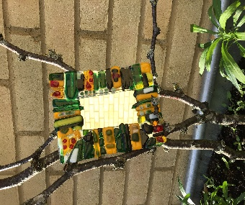 | 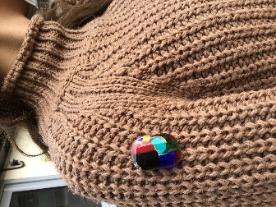 | 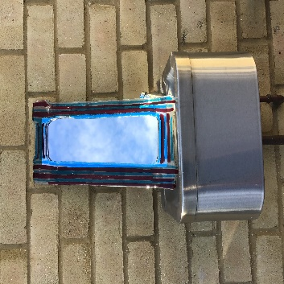

VACCINATIONS
The vaccination is now available for the elderly in our communities and it is quickly moving down the age bracket. Ealing have set up a system for staff in schools to have the vaccination in order to facilitate the process of reopening schools in a safe manner. This is NOT for students!

HALF TERM
Monday 15th – Friday 19th February is Half Term. The term will start again, as we are currently operating, to ONLY key worker and vulnerable students, on Monday 22 February. The college will reopen fully once the Government makes their announcement and the Head Teacher decides that it is safe to do so. You will be informed.

*ADVANCE NOTICE 2021*

Monday 8th – Friday 12th March – Science Week/Employability Week (dependent on current regulations)

Wednesday 24th March – Post 16 End of Term @ 3:00pm

Thursday 25th – Wednesday 31st March – Post 16 Transition/Learning Conversations

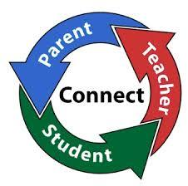

Internet and Phone Safety

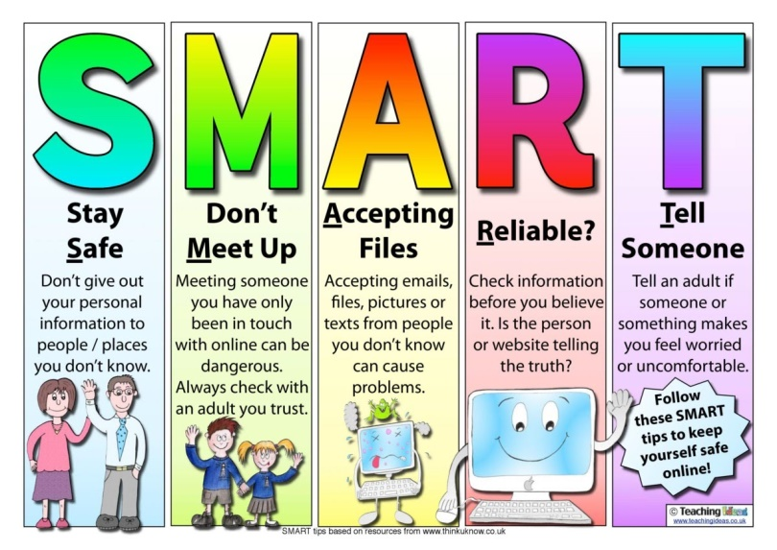
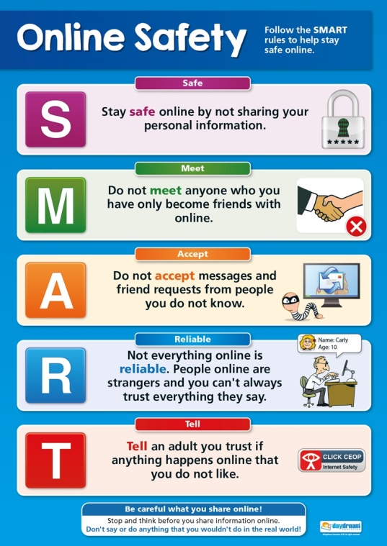
We are hearing about incidences of students using their phone and other devices inappropriately.
Please be aware that due to the age of our students the laws that apply to them are different than when they were in the main school and some things are illegal.
Remember that anything posted, uploaded or sent can be seen and will probably remain visible for years to come and can be shared by others and then by others in turn; meaning that it can end up anywhere!
Therefore, if it is something they would not like you or any other adult to see, read or hear, they should be very careful!

