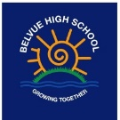
Intent
Theatre is at its best when it excites and incites. Theatre provokes action, it challenges complacency, it demands attention and challenges ways that things have always been done. It is a rebellion, a voice, a focus, an engagement, a solution, a platform for everyone and anyone. Nobody is exempt.
The Drama Department at Belvue High School is committed to delivering a curriculum that at its core lies play. It serves to enrich and empower all of our learners.
The aims are to develop self –discipline, team work and communication and to nurture a sense of self and belonging to a group/community.
Through creating, performing and evaluating their own and others’ work, it is hoped that the curriculum will inspire our Belvue learners to value their experiences, take risks, explore and give a platform for their voices and stories to be heard.
Overview

Drama is divided into THREE key areas in line with the National Curriculum:

- Physical
- Vocal
- Performance
Weekly Drama lessons for Key Stage 3 are structured to embed the three key areas, and are recorded on Classroom Monitor and Individual Learning journeys. A weekly lesson is dedicated to these three key areas, where students work in small groups and receive 1:1 input from class teachers and TA’s. Students explore various drama activities and tasks to develop performance skills and to support them with cross-curricular skills e.g. Speaking and listening, working as a team, storytelling, confidence, and developing presentation skills.
Over a 2 year period, Key Stage 4, MLD students follow the WJEC accreditations in exploring physical and vocal techniques as well as performing in front of an audience. Learners will work towards achieving an Entry 2/3 in the following areas or will receive a Belvue certificate in:
- Using the voice in a dramatic context
- Using the body in a dramatic context
Contribute to the creation of a group drama presentation
Drama

Autumn | Spring | Summer
MLD: Explore storytelling in performance.  SLD: perform known short stories | MLD: Exploring advertising and create and advert.  SLD: Creating a “photo advert strip” | MLD: Devise scripted scenes on experiences  SLD: Improvise/mime given scenarios scenes
Students will study different genres and identify the features that differentiate them.  They will explore the storyline using a storyboard or writing frame to outline the beginning, middle, climax and end. They will explore the characters and setting within the story and build characters and identify relationships between them. To extend their learning they will make predictions and write/devise dialogue between characters. Learners will rehearse with their script to develop a performance for an audience. | Students will identify the features and techniques of an advert either in print or audio visual. This will enable them to create their own advert and film it.  During this term the students will also study instructions, their key elements and the type of language used. They will create an advert for film or TV in small groups. | Students will draw upon the experiences of others, through autobiographies, bibliographies, interviewing friends or scripts. They will take part in class discussions, debates and hot seating. They will carry out peer interviews and be supported to relate to others and make comparisons between their experiences and that of characters. The students will communicate their findings in the form of a performance/presentation.
MLD: Physical theatre/comic books/existing stories (Jacques Lecoq.  SLD: Comic books – using tableaux | MLD: Exploring and presenting a scene/work from Shakespeare.  SLD: photobook of scenes from Shakespeare.(mime/photobook) | MLD: Devised Poetry programmes /performance project exploring past experiences and theme.  SLD: Devised Poetry programmes /performance project exploring past experiences and theme using tableaux and photobook.
Students will study and explore a narrative in small groups. In some classes they will study more than one narrative across different genres and draw upon comparisons. Students will have the opportunity to take part in role play, discussions, debates and outdoor learning.  They will develop an in-depth understanding of the story and the characters within it. They will have the opportunity to express their opinions about act out the story and explore playing characters. They will be learning about: relating themes, characters, direction, staging, team work and production with the over aching aim to develop a love of drama and storytelling. | Students will learn about the style of Shakespeare and perform/improvise scenes his plays, such as Romeo and Juliet, Macbeth, Twelfth Night and Hamlet.  They will follow the story/scenes through listening or reading sections of the original play and reading a simplified version of the whole play/scenes as a guided activities. They may watch different film versions and gain a deeper understanding through role play and class discussions.  They will learn to identify and describe the setting, main characters, plot development and discover the relationships between characters and the effect/s they have on the audience. They will perform in front of an audience. | Students will be engaging in emotional performance work (Stanislavsky). They will be drawing upon personal past experiences such as holidays and celebrations. They will be supported to reflect and recall their experiences through questioning. During group work they will develop their speaking and listening skills by identifying similarities and differences between their experiences.  The students will communicate their experiences in a performance.  They will develop their comprehension and inference skills through finding key information in the sharing and performing/presenting experiences.
MLD: Devising short stories (genre/Lecoq)  SLD: Devising short stories through tableaux (known stories) | MLD: Film/script writing-develop own poetry programmes.  SLD: poetry in song/tableaux/photobook/film. | MLD: Filming/performing a documentary about new experiences/future  SLD: Filming/performing a documentary about new experiences/future (hand over hand/guided)
Students will study the features of a narrative enabling them to create their own story. They will learn to plan and sequence their ideas using a story board or writing frame; and develop their language and vocabulary skills with the purpose to perform for an audience. The students will be encouraged to relate to their senses to create presentations with elements of character, costume and setting.  They will have the opportunity to share their stories with others in a performance. | Students will study a range of poetry, identifying features and learning to recognise rhyme, rhythm, alliteration, similes and metaphor. In groups class they will interpret the subject matter and theme of poems. Learners will identify the underlining emotions and purpose of the poem. Students will have the opportunity to write or learn existing poems and perform poetry programmes for others.  They will explore the differing language of poetry and how they could be performed for an audience. | Students will take an active part in a variety of experiences, such as a treasure hunt, going on a trip and develop/devise a performance that reflects their stories. Each experience will lend itself to a range of performing and communicating purposes.  The students will be encouraged to engage with their senses and emotions to help them to understand the affect the experience is having on them and others. They will develop their communications skills through class discussions, taking part in presentations, hot seating and role play.  The students will develop their communication and language skills by recording their experience in different ways such as presentations and photobooks. They will develop their thinking, planning and organisation skills though arranging an experience for a specific target audience.

Drama

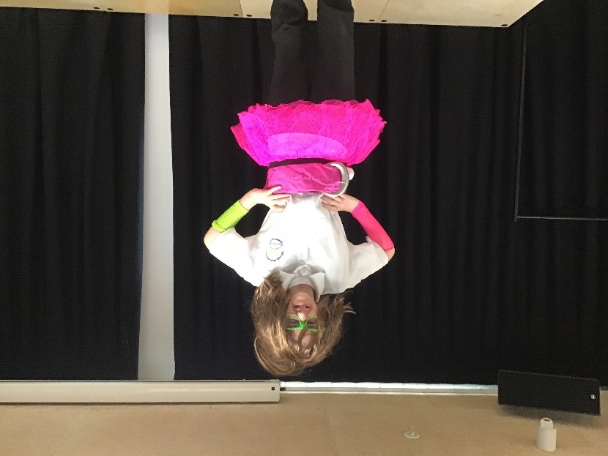
Rehearsing for Cinderella. Chloe plays one of the Ugly sisters.

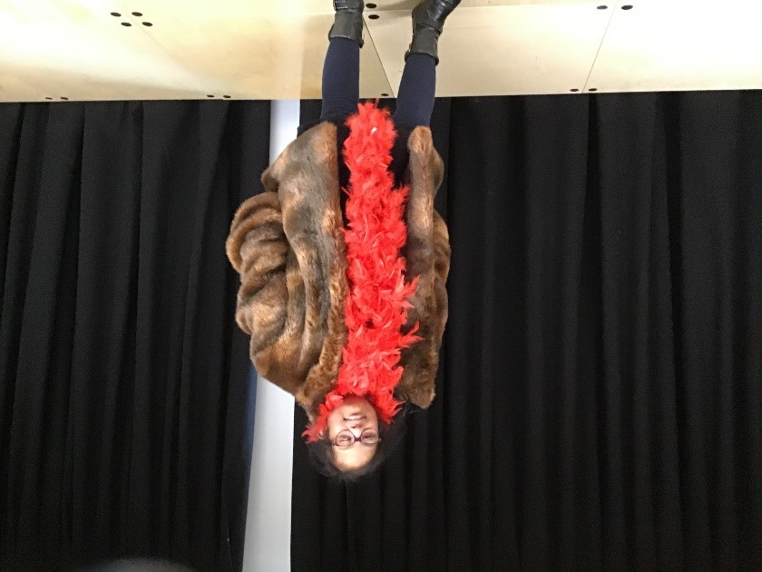
Rehearsing for Cinderella. The nasty step-mother.

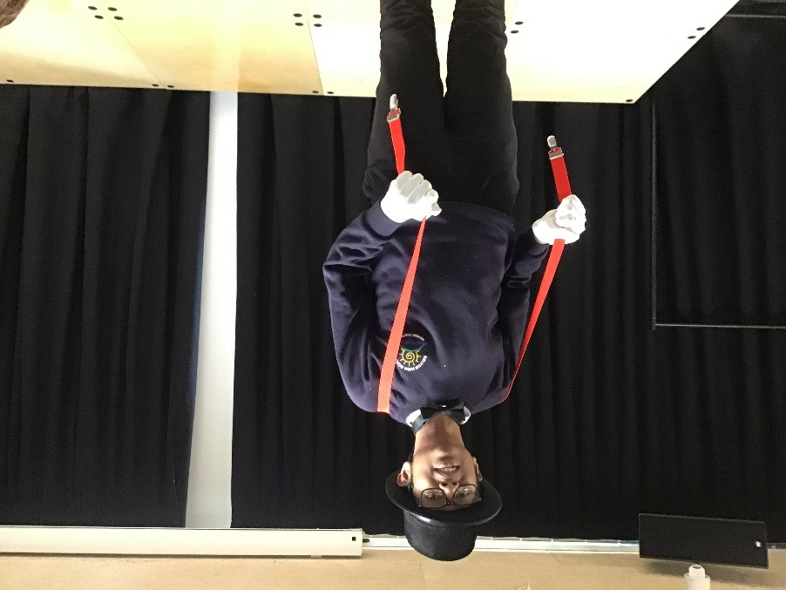
Pranav. Playing the narrator in Cinderella.

