**Core Strength Exercises.**

* **Drawing in your ABS.**
* Think about your belly button pulling inwards from your pantline, hold for five breaths, and then relax.



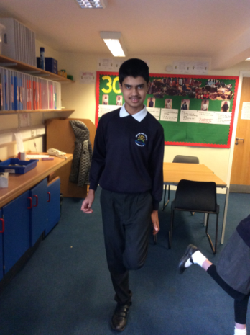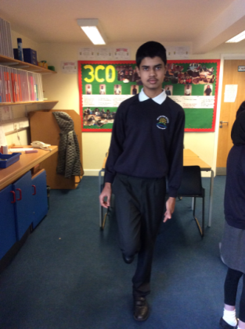

* **Standing on one leg.**
* Try and balance for as long as possible.
* Make sure you alternate legs.

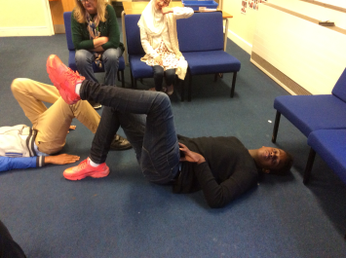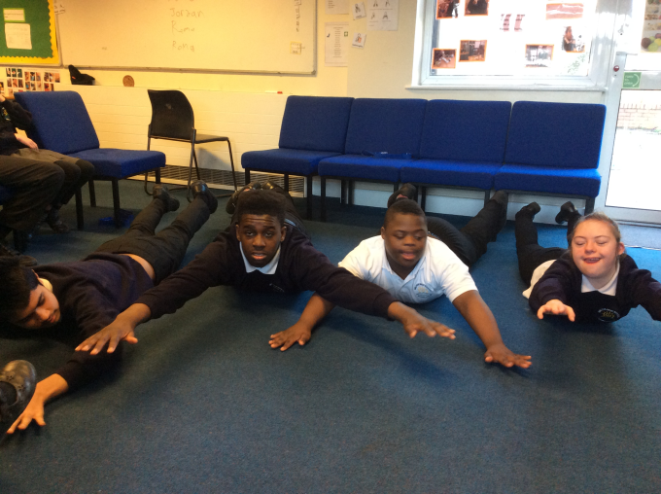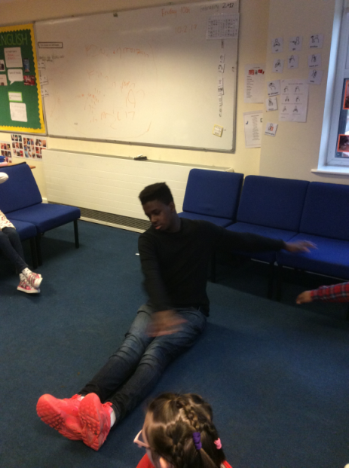 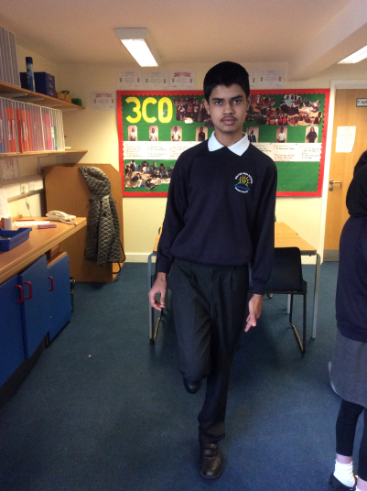

* **Toe Taps.**
* Lie on your back, knees bent, feet flat on the floor.
* Lift your left leg to tabletop position x10
* Lift your right leg to tabletop position x10
* Must be a slow and controlled movement.
* **Superman.**
* Lie flat on your stomach, arms stretched out in front of you.
* Lift up both hands and your head off the floor.
* Extension: Lift both feet and arms off the floor at the same time.
* **Spine Twist.**
* Sit with legs straight out in front of you, back straight with arms out wide.
* Then slowly twist from side to side, controlling your breathing.
* X10 each side – must be a slow and controlled movement.

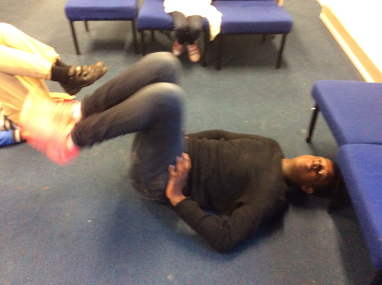

* **Double Leg Toe Taps.**
* Lie on your back, knees bent and feet flat on the floor.
* Lift your feet in the air, keeping your knees bent.
* X10 must be a slow and controlled movement.
* Extension:
* Hold knees in set position and perform 10 crunches.
* **Leg Raises.**
* Lie on your back, hands by your side, legs straight.
* Lift up your legs.
* Extension: Do not let your feet touch the floor and rest.

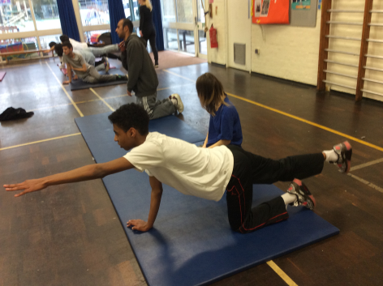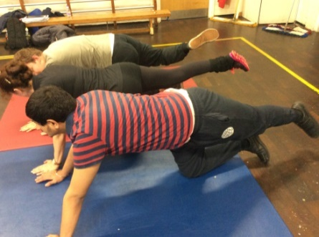

Extension: Extend opposite arm.

* **All fours extension.**
* Start on all fours, back straight. Lift and extend your right leg back hold for 5 seconds, alternate legs slowly. X10

Extension.

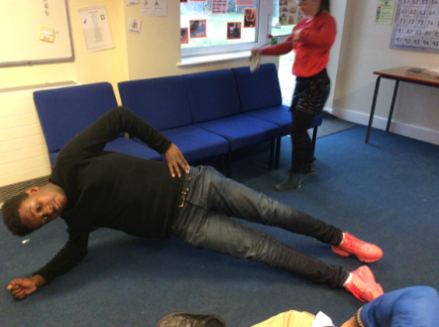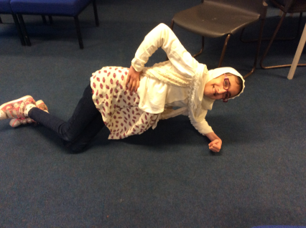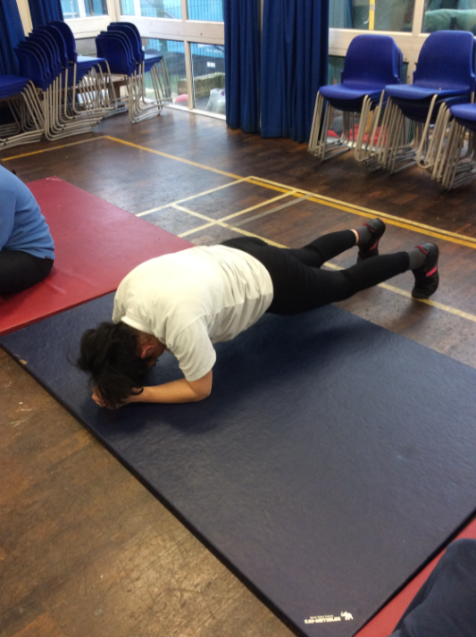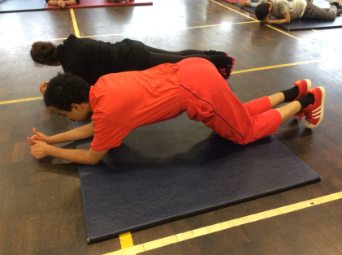

Extension.

* **Side Plank.**
* Aim to hold each plank for 30 seconds. Make sure your alternate sides.
* **Plank.**
* Back/body must be straight.
* Start on knees.
* Progress onto feet.
* Hold for as long as possible.

