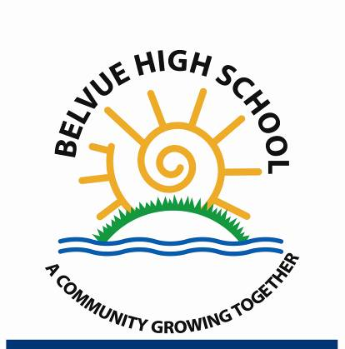
Year 7

Catch up Premium

2018-19

- Catch up Premium Summary
Financial Year Amount of Catch up Funding
2014/15 |  |  | £8500
2015/16 |  |  | £11500
2016/17 |  |  | £10000
2017/18 |  |  | £9500
2018/19 |  |  | £15,000
2019/20 |  |  | £10,500
Catch up premium | 2016/17 | 2017/18 |  | 2018/19 | 2019/20
Number of pupils eligible for catch up premium | 20 | 17 |  | 21 | 12
Number of looked after pupils  eligible catch up premium | 1 | 0 |  | 0 | 0

Nature of support 2019/20
Year 7 Catch Up is additional Funding given to secondary schools to help all pupils who did not achieve the expected outcome at the of Key Stage 2 tests. In 2019/20 Belvue School received £10,000. The focus for Catch up funding this year was to provide direct support for developing speaking and listening with individual and small groups through singing. The school had witnessed over the last two years the impact of singing on pupil’s communication and confidence in speaking in small groups and publicly (assemblies, school performance and school council). It was decided to appoint a specialist singing teacher to work with individuals and groups of pupils on learning and performing a range of contemporary and traditional songs in order to support pupil’s confidence and use of communication skills.

- Pupil Progress data - Measuring the impact of catch up spending
Pupil progress is analysed formatively using a range of assessment tools including classroom monitor, end of unit tests, teacher observation, annual review targets, ROA and learning journeys. Pupil progress is recorded at least termly using the Key Performance Indicators on Classroom Monitor and this information is used to track progress across the curriculum and to allow Curriculum Leaders to analyse summative data for their area of responsibility. This system also allows Curriculum Leaders to analyse summative data for their area of responsibility to ensure that all pupils are making expected level of progress (as judged against their starting point). The data also provides information and feedback to Curriculum Leaders on how effective their curriculum intent and implementation is, and therefore provides an evidence base for school improvement. The data is broken down into outcomes for a number of different groups to allow for comparative analyse. Throughout the year there are regular progress/moderation meetings to focus on individual pupils’ progress against the Key Performance Indicators for our newly revised curriculum. These KPI’s have been identified to allow the school to assess pupils ‘without levels’. Moderation of pupil’s work and analysis of classroom monitor enable targeted support to be provided where necessary to improve attainment and outcome for individual and groups of pupils. Each term pupils with less than expected progress in the core subjects are identified by the subject leader and distributed to Class Teachers and discussed at the termly progress meeting with SLT.
3. Other outcomes identified
- Increased confidence and progress across other subjects with pupils making an average of VA across the core subjects.
- Learning intentions -
- Improved behavior – merit data
- reduction in detentions – detention data
- Increased self-esteem – measured through for example, PTOS (Psychological Therapies Outcome Scale).
- Decreased levels of anxiety- as measured above
- Improved confidence with Reading.
- Pupil engagement and enjoyment of the singing programme
- Pupils increased confidence in participating in performances and assemblies
- Looked after Children – 2019/20
There were no Looked After Children in the 2019/ co20hort.

5. Evaluation from 2019/20
FOCUS 1 - The appointment of an additional specialist music assistant to increase targeted support for communication and development of speaking and listening skills. The aim of the project is to continue with: | Budget | OUTCOME:  Pupils made good progress towards their targets. By good we mean that they met or exceed their Maths and English target for the year; increase their independence in all aspects of their work in school and met their annual IEP targets. Their attendance is also over 95% which demonstrates that they enjoy and value coming to school. Good progress is also demonstrated by good and improving behaviour.
 | 10,500
Having fun communicating through singing solo and in groups | to support the development of communication skills
Learning new songs through memory | to support the working memory and increase vocabulary
Learning new songs through reading the words | increase sight vocabulary
Performing songs to a variety of audiences | increase confidence and well-being
Empowering young people through using their voice to perform | Increase confidence and sense of well-being
Extending pupils awareness of the range of sung music by listening and discussing likes and dislikes | To promote social interaction, confidence and independent skills

