Going Back to School

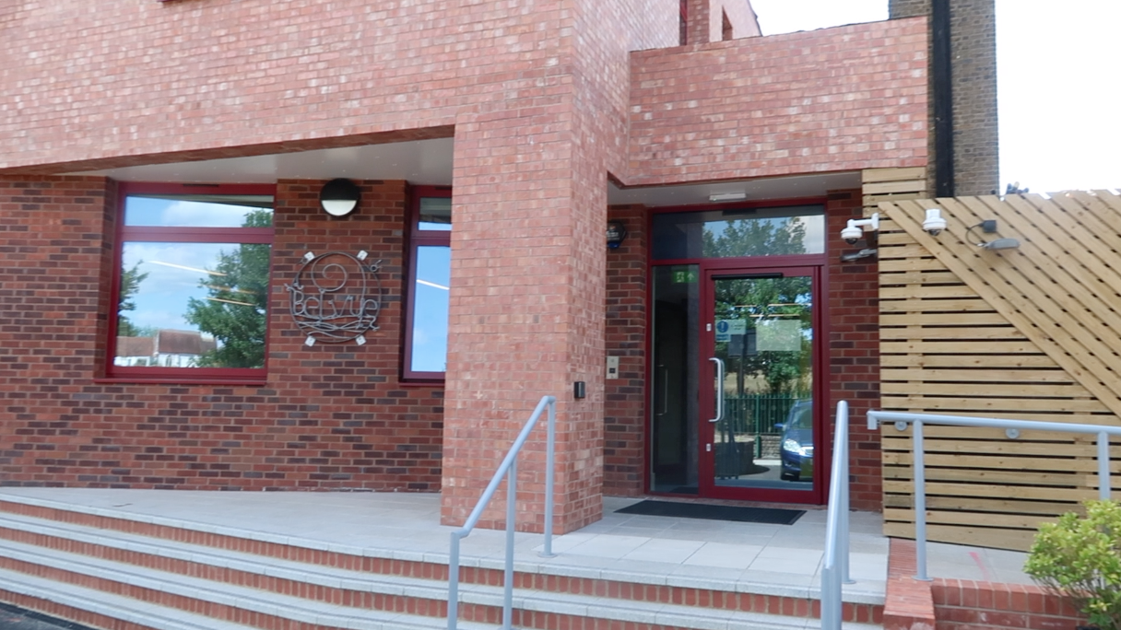

In September everyone will be going back to school. I will be going to my school, Belvue. Many things will be the same. I will be able to see my teachers and friends at school.

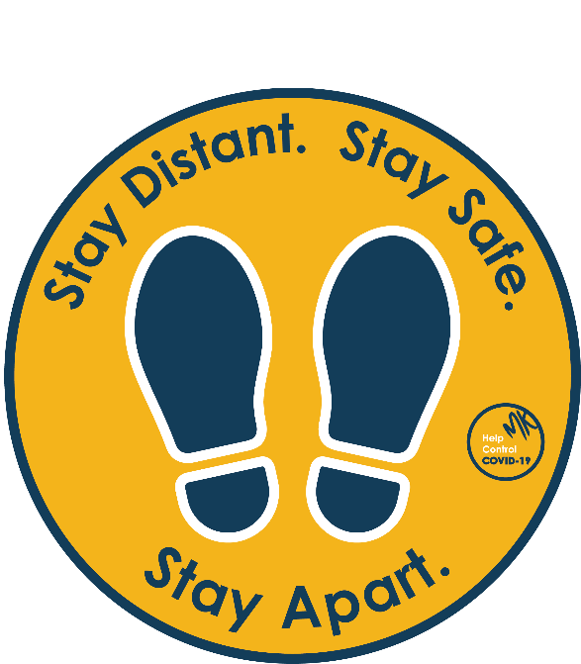

Some things may be different because of the coronavirus. These changes are to keep us safe. My teachers will show me what to do.

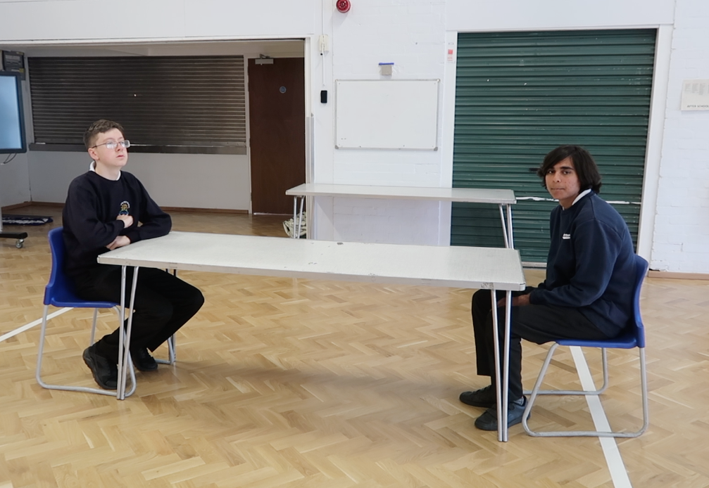

I will need to use social distancing when I am at school. This means that I must stand or sit apart from my friends and teachers. We are still friends.

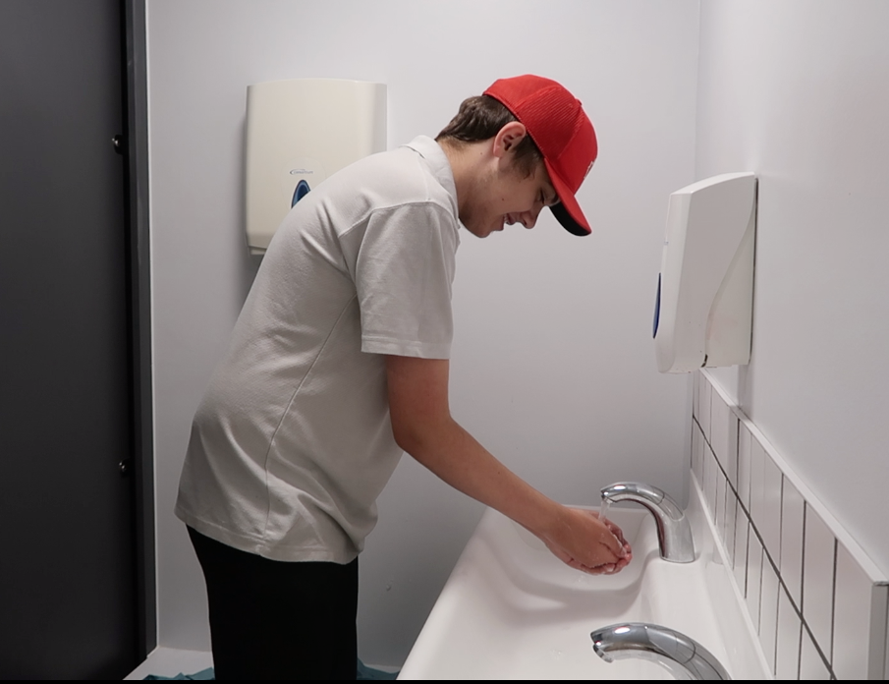

I will need to wash my hands often. My teachers will tell me when I need to wash my hands.

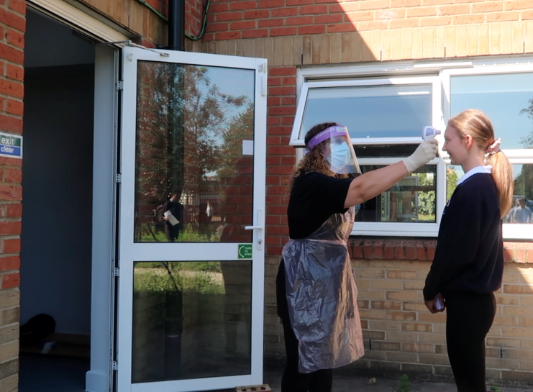

When I get to school, my teachers will take my temperature.

Then I will wash my hands and go to my classroom.

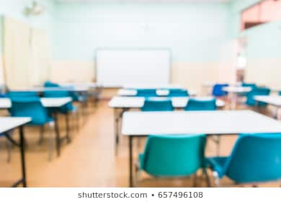

My classroom may look different. The desks may be facing a different way. This is ok.

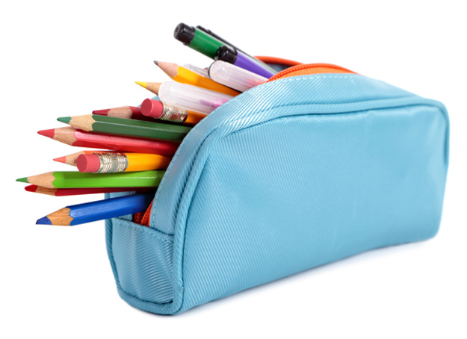

I can bring my pencil case and water bottle into school. I will leave them with my diary at school at the end of each day in my classroom. This is ok.

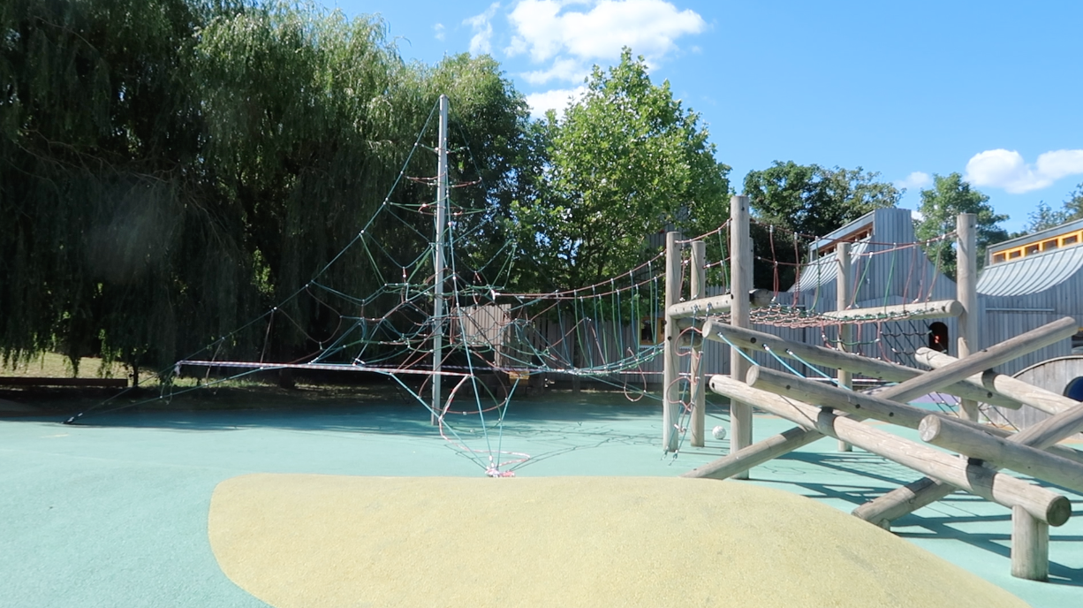

When I am in school, I will stay in my group. This means I will stay with my group when we are outside or in the playground. This is OK.

I will be going to school in September. I will see my friends and my teachers. Many things will be the same. Some things may be different. This is ok. My teachers and my friends will help me.

