POST 16 NEWSLETTER – APRIL 2021

COLLEGE LUNCHES!!
You will have received a text regarding your child needing to bring a packed lunch for the first week back (Monday 19 – Friday 23 April). This is due to an electrical issue which caused the fridge and freezer to stop working causing required food for the term to spoil.

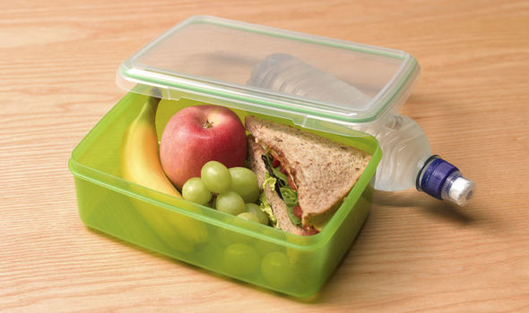

TRANSITION/LEARNING CONVERSATIONS
Thank you for attending your child’s Learning Conversation. Your cooperation during this difficult time has been great. The Google Meet or phone call conversations were a success. If you have not managed to have your meeting, please ensure that this takes place during the first two weeks back after the Easter break.

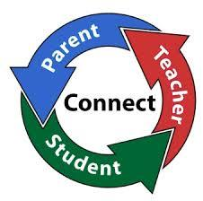
TRANSITION FROM BELVUE
For any students who will be leaving Belvue in June the process of their transition will be in hand following on from their annual review. We will support the process for any of our students who are or who are approaching their 18th birthday and will be moving over to the adult disability team. This is to ensure that you receive the appropriate services once you leave us.

CORONAVIRUS TESTING
Any students that had agreed to a test, have been given a number of rapid tests to take home. Hopefully they were able to undertake the tests successfully independently or with your help.
The government will also be rolling out this service to adults too, so it will become more of a regular process that all people get used too.
This is a personal choice and we are aware that not all students are able to do so.

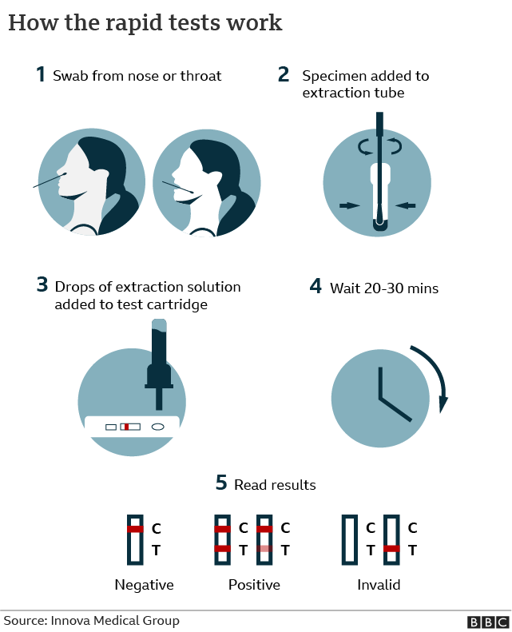

RISK ASSESSMENT
While in college students will be reminded and expected to continue to follow government guidelines and the college risk assessment rules regarding temperature taking, social distance, face covering (including removing them correctly), hand washing/sanitising and moving around the building safely.

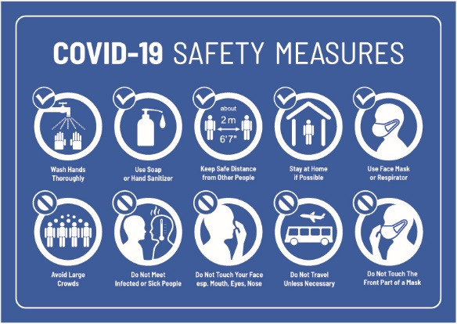

COURSEWORK / EXAMS
In the next few weeks students will be working hard to complete their coursework and exams. Although the government have allowed certain allowances for particular exams and qualifications the work still has to be undertaken and filed away for external moderation. If your child is undertaking a Functional Skills qualification please ensure that they are doing additional work at home e.g. learning their spellings, timetables, writing sentences, reading, etc.

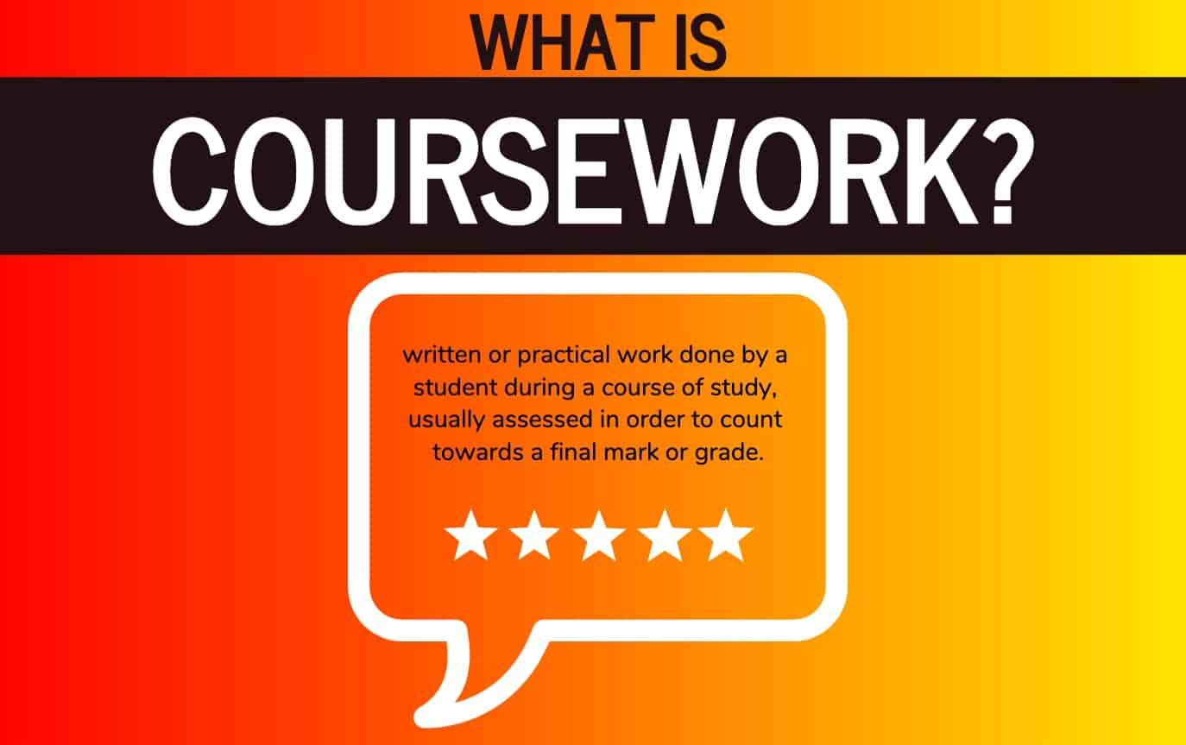

SMASHING GLASS
Belvue’s Glass Enterprise will be selling their products through the college. There is a mixture of jewellery (e.g. pendants/necklaces, earrings and broches) and items for the home (e.g. decorations, mirrors, coasters, small bowls) that you can buy. Prices range from £4 - £15. Please let us know if you are interested in purchasing anything. There is always a festival or celebration around the corner e.g. Mother’s Day and it is an ideal time to buy something for a loved one or friend.

 | 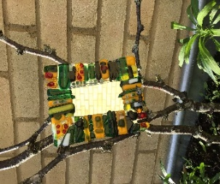 | 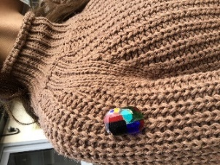 | 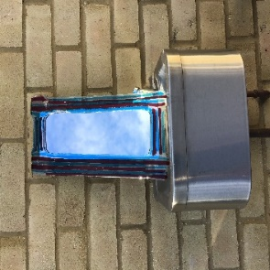

CONTACTING STAFF
If you have any concerns regarding anything while your child is at the college please contact us to book an appointment or to speak to someone on: 020 8422 0372

*ADVANCE NOTICE 2021*

Friday 30 April – Training Day (College Closed)

Monday 3 May – May Day (College Closed)

Thursday 6 May – Election Day (College Closed)

Monday 31 May – Friday 4 June – Half Term

Friday 25 June – End of Year (Last Day of College)

31/05 - 04/06

We are hoping to have a socially distanced
Graduation event in June –
More information will be published nearer the time.

Internet and Phone Safety

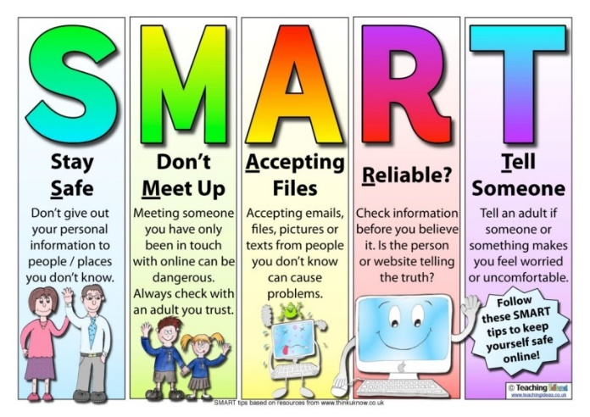
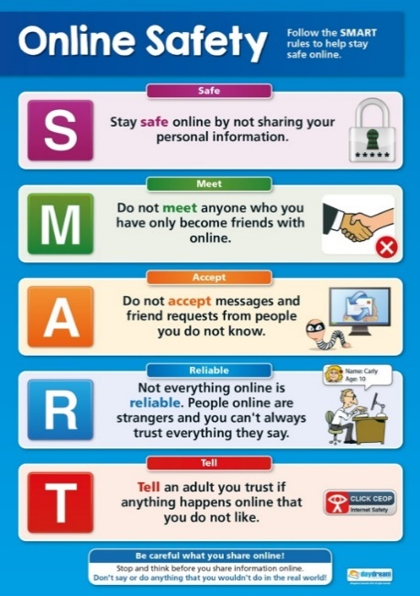
We are hearing about incidences of students using their phone and other devices inappropriately.
Please be aware that due to the age of our students the laws that apply to them are different than when they were in the main school and some things are illegal.
Remember that anything posted, uploaded or sent can be seen and will probably remain visible for years to come and can be shared by others and then by others in turn; meaning that it can end up anywhere!
Therefore, if it is something they would not like you or any other adult to see, read or hear, they should be very careful!
The police will be informed of any material passed between students that are harmful or illegal in nature.

