POST 16 NEWSLETTER – SEPTEMBER 2019

WELCOME
A very warm welcome, to our students at the start of this new academic year.
We are sad to have had two members of staff transferred back to Belvue High School (Mr Prophet, Ms McKenzie) and one who has moved on to new things (Ms Collins), but are pleased to welcome our three new transferred members of the Belvue school team into Post 16. Therefore, as well as Mr Shipton-5BS, Mr Peterson-5PP and Miss Gibson-5JG, we now also have Mrs Buchan-5LB, Mrs Heaney-5AH and Mrs Petrakou-5FP.
As is the custom, many students coming into Year 13/14 have changed classes to accommodate a young person’s academic ability, emotional needs, level of independence and social skills.
The team are excited about an inspiring new curriculum that we have created for Post 16 and are eager to convey it to our students. We are hoping for a refreshing and stimulating new year.

Ken Phone Number: 020 8422 0372
belvuecollege@belvue.ealing.sch.uk
Please use this number to let us know if your child is running late, is ill or if you have an appointment.

COLLEGE TIMES
College starts at 8:45 and finishes at 3:30 on Mondays, Tuesdays and Wednesdays and at 2:45 on Thursdays and Fridays.
Break is at 11:00-11:15 and lunch is from 12:30-1:30.

AFTERCOLLEGE CLUBS
Clubs will run on Monday – Wednesday from 3:30 – 4:45 starting on Monday 23 September.
You will need to complete the necessary form and pay the allocated amount before the start of the club.

Clubs will run on Monday, Tuesday and Wednesday. These will be confirmed soon.

COLLEGE DRESS CODE AND WORK UNIFORMS
You will have been sent a letter informing you that the college dress code has changed and received a text reminding you of this fact.
Your child is expected to come to college dressed accordingly and appropriately.
In addition, your child will be given a work uniform which he/she is expected to wear on allocated days related to their timetable.
Please also ensure that your child is wearing the correct footwear e.g. boots

TIMETABLE REQUIREMENTS

Subject | Meet at | Lunch | Kit
Computing: Ealing Education Centre | The Venue | Packed lunch | N/A
Community | Ken | Packed lunch | Work uniform
Hanwell Zoo | Ken | Packed lunch | Work uniform
Hospitality and Catering:  Southall College | Ken or Direct to College | Packed lunch or as advised | Kitchen whites
Litten | Ken | Packed lunch | Work uniform
NHS | The Venue or Northolt Tube | Packed lunch | Work uniform
Retail: Southall College | Ken | Packed lunch | Work uniform
Welshore Hub  Shop | Ken or Direct to shop | Packed lunch or money for food | Work uniform
All other times your child can have a school lunch £2 or bring in a packed lunch.
The college meals are all vegetarian with an occasional fish/meat dish during the year.
Please call for more information if unsure about anything.
FREEDOM PASSES AND OYSTER ZIP CARDS
Please ensure that your child has an up-to-date Freedom Pass or Oyster Zip Card for the new academic term 2019/20. It is important that your child brings their card into college every day, even if they are non-independent.

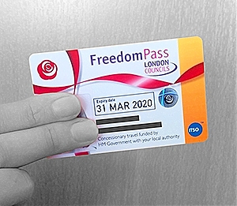
TRAVEL TRAINING PACKAGES
If your child is not on school transport, but you would like support with their travel training to college, Mencap offer a Travel Buddy Service costing £14 per hour, which could help. You can contact them using the information below.
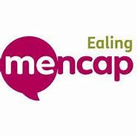
Travel Buddy Service Manager
The Lido Centre
63 Mattock Lane
West Ealing
London
W13 9LA
0208 280 2265
travel.training@ealingmencap.org.uk

NUS CARD
Belvue College are pleased to announce that we have successfully registered with the National Union of Students.
The card can be used in a number of popular establishments e.g. McDonald’s, different cinemas, the Co-op, Superdrug, Domino Pizza, phone shops, etc. and allows students to purchase things for less money, so take your child shopping with you and get them to use their card.
The cost of the card is shown below.
Belvue College students can buy a card for more than one year, (but you may want to try it out first).
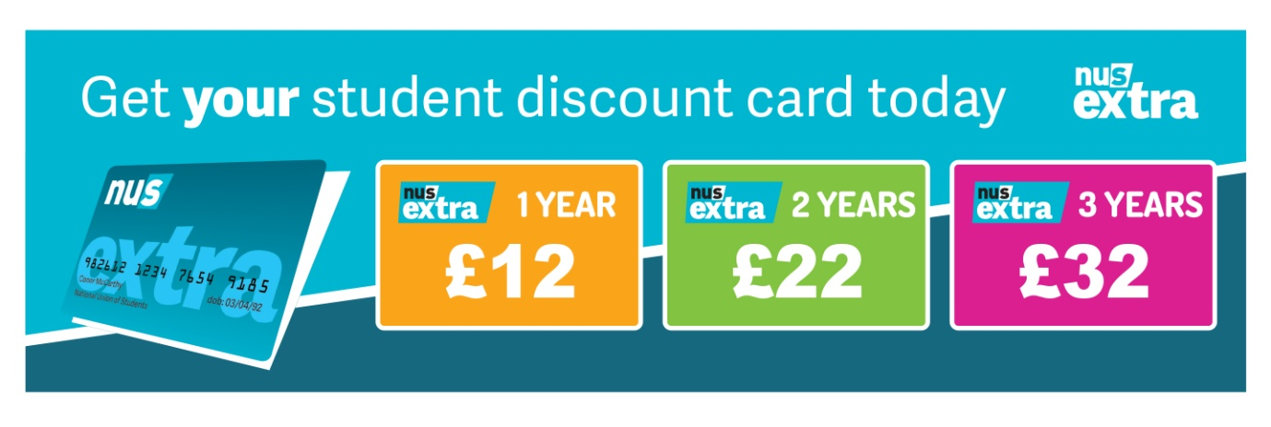

RESIDENTIAL
We are in the process of exploring and booking our Year 13/14 residential.
The trip will be organised for the summer term (May or June) 2020.
This is a trip that all students remember and want to always go again in order to have fun and relax with their friends.

More information will be given in the next newsletter.

*IMPORTANT ADVANCE INFORMATION*
Many of our calendar dates are different from the main school

COLLEGE CLOSED
Friday 18th October Occasional Day – School Closed
​Monday 21st – Friday 25th October Half Term
Monday 28th October Occasional Day – School Closed

THURSDAY 21 NOVEMBER
Transition Evening – this is an opportunity to obtain information regarding your child’s future after Post 16 by hearing from different organisations, including colleges, Mencap, NCS The Challenge and Connexions.

FRIDAY 13 DECEMBER
END OF TERM – last day of term for all Post 16s. Students are expected in school on this day.

MONDAY 16 – FRIDAY 20 DECEMBER
ANNUAL REVIEWS – your child must accompany you to their annual review. Connexions will be present to give you impartial advice and information about what is available for your child when they leave Belvue College.
If there are any days, dates or times during that week that you cannot do, can you let the college office know by the Friday 27 September as your invitation slot will to be sent out in October.
If you would like to see your child’s VT/class teacher or Miss Gibson call the college office to book an appointment.

