POST 16 NEWSLETTER – NOVEMBER 2019

Just a reminder regarding uniform, hoodies, sportswear, ripped jeans, etc. are not college wear and your child will be given clothes to wear if they arrive dressed inappropriately.

PUPIL PATHWAY EVENT
The first ‘Preparing for Adulthood’ event was held on Wednesday 30th October at Westside in West Ealing. It was attended by a number of organisations in the borough who are there to support and help you and your child. Do not worry if you missed this one, as many of the attendees will also be at our transition evening (see below) and they are also hoping to hold another event in the Spring Term. This is a great opportunity to have your questions answered about your child and their future needs.

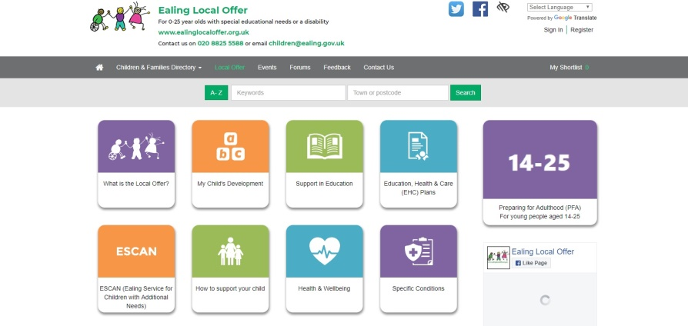

THURSDAY 21 NOVEMBER
Transition Evening 5:30-7:00pm – this is an opportunity to obtain information regarding your child’s future after Post 16 by hearing from different organisations, including local colleges, Mencap, NCS The Challenge, Connexions, etc. It is especially important for parents of any students who will be leaving Belvue College next year June 2020.

LUNCH TIME / AFTER COLLEGE CLUBS
Every break and lunch time at the college students have a timetable of regular activities that are undertaken by the staff on duty e.g. football, basketball, cricket, skipping, parachute, hula hoops, etc.
In addition to these we have specific lunch time clubs from 1:00 – 1:30 and after college clubs (there is a charge for these) run from 3:30 – 4:45.

 | Monday | Tuesday | Wednesday | Thursday | Friday
After College | Beauty Club  Gaming Clb | Youth Club | Art Club

RESIDENTIAL
Monday 8 – Friday 12 June – Thank you for showing your interest in the Year 13/14 residential. There are a limited amount of spaces so please get your deposit in as soon as possible. The venue is one which we have used before and our students and parents really enjoyed it.

.

.
COLLEGE WINTER BAZAAR
WEDNESDAY 4 DECEMBER – Belvue College will be holding their first Winter Bazaar. Please come and support our young people as they sell their crafts, bric-a-brac, gifts, tombola, cakes creative glass jewellery, lanterns, mirrors, etc. There will also be a small café for you to relax in after you have done all your shopping.

WEDNESDAY 11 DECEMBER
Post 16 students will be having their Christmas lunch. This is a time for students to dress up and enjoy a wonderful meal and a fun time together with their friends and staff.

THURSDAY 12 DECEMBER
All classes will be going out on this day for their Christmas Treats. The classes will decide together where they would like to go and how much the trip will cost. A letter will be sent nearer the time outlining all the necessary information.

FRIDAY 13 DECEMBER
END OF TERM – last day of term for all Post 16s. Students are expected in school on this day. The day ends at 2:45

MONDAY 16 – FRIDAY 20 DECEMBER
ANNUAL REVIEWS – your child must accompany you to their annual review. Connexions will be present to give you impartial advice and information about what is available for your child when they leave Belvue College.

.

NUS CARD
Belvue College are pleased to announce that we have successfully registered with the National Union of Students.
The card can be used in a number of popular establishments e.g. McDonald’s, different cinemas, the Co-op, Superdrug, Domino Pizza, phone shops, etc. and allows students to purchase things for less money, so take your child shopping with you and get them to use their card.
Prices have now changed – 1 year = £14.99
https://www.totum.com/nus-extra

IMPORTANT
Please use this number to let us know if your child is running late, is ill or if you have an appointment

Ken Phone Number: 020 8422 0372
belvuecollege@belvue.ealing.sch.uk

