POST 16 NEWSLETTER – SEPTEMBER 2017

WELCOME
Once again, we would like to welcome our 62 students to a new academic term.
The students have been amazing dealing with all the changes, coming to terms with their timetables and moving to the different sites and venues.

We also want to thank our parents/carers for your patience in assisting us during this week in following your child’s timetable and getting them to the correct places.

To support and assist parents/carers with the transition and understanding your child’s timetable, lunches, etc., Mr Roberts and Miss Gibson will be holding ‘open times’ at the Ken Acock and Northolt High sites week beginning 25th September.
You can book appointments via the college office – they can be in person or you can telephone them during a given time.

Northolt Phone Number: 07 391 174013
Ken Phone Number: 020 8422 0372
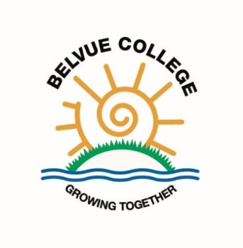

COLLEGE TIMES
College starts at 8:45. Please ensure your child does not arrive at any of the sites early, especially at the Northolt site.

College finishes at 3:15 on Monday, Thursday and Friday and at 2:45 on Tuesday and Wednesday.

RESIDENTIAL
We are in the process of exploring a new venue for our Post 16 residential as there are so many of us now. The trip will be organised for the summer term 2018. Please start saving from now!
More information will be given in the next newsletter.

TIMETABLE OVERVIEW

Subject | Meet at | Lunch | Kit
Catering | Ken | School lunch | Kitchen whites
Environment | Ken | Packed lunch | Work uniform
Horsenden | Ken | Packed lunch | Work uniform
Childcare | Northolt | School meal or  Packed lunch | /
Enterprise | Northolt | School meal or  Packed lunch | Work uniform
Hospitality | Belvue | School lunch | Work uniform
Independent Living  Southall College | Belvue | Packed lunch | /
Litten | Belvue | Packed lunch | Work uniform
Hanwell Zoo | Belvue | Packed lunch | Work uniform
Community Work | Belvue | Packed lunch | Work uniform
Computing Redwood | Belvue | Packed lunch | /
Welshore Hub  Shop | Belvue or direct to shop | Packed lunch or Money for food | Work uniform
Hospitality and Catering  Southall College | Belvue or direct to College | Packed lunch | Kitchen whites

WORK UNIFORMS
Reminder, if you need your child’s uniform adjusting please send the item of clothing onto school with a letter explaining what is needed.

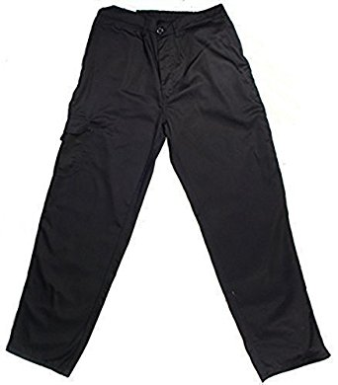

IMPORTANT ADVANCE INFORMATION
November 16
Transition Evening – this is an opportunity to obtain information regarding your child’s future after Post 16 by hearing from different organisations, including colleges, Mencap, NCS The Challenge and Connexions.

December 8
End of term – students are expected in school on this day .

December 8-15
Annual Reviews – your child must accompany you to their annual review. Connexions will be present to give you impartial advice and information about what is available for your child when they leave Belvue College.

