Science Week
BRIEF DESCRIPTION OF THE PROJECT:
As part of the school’s ongoing self-evaluation it was evident that students loved the practical subjects, this was also identified by the previous Ofsted visit, “…pupils are motivated by the practical activities which help them achieve well.” (Ofsted Report, 2004). We engaged with students about their preferences and it was clear from their responses that they loved participating in experiments; making predictions and then being wowed by the reactions carried out – especially those that were not every day occurrences but linked to everyday objects (e.g. spinning water in a bucket and not spilling it).
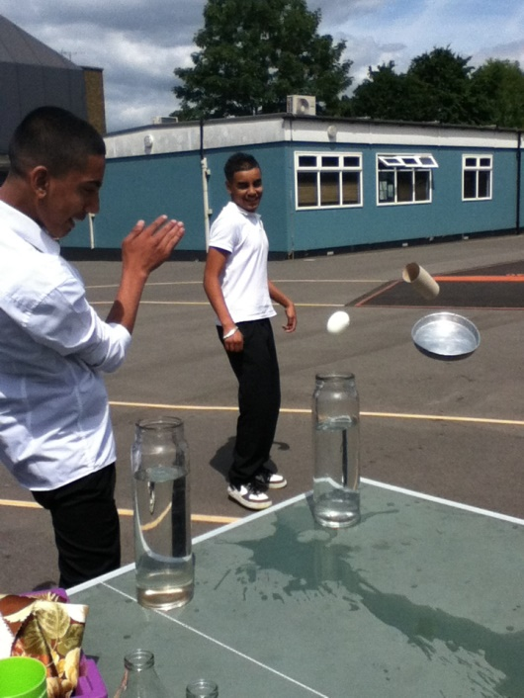
MLD students taking the mystery out of famous magic tricks
Data analysis from 2014 for Key Stage 3 pupils demonstrated that progress in science was not happening at the same level as that of English and Maths. That year 77.8% of pupils met their targets for English and Maths compared to only 55% for science. This led us to question how we could reintroduce the awe and wonder that is usually typical of a science curriculum.
Chapman and Feldman (2016) found that “…the students believed the experience to be one of authentic science, that their science identity was positively influenced by participation in the experience, and that they demonstrated a shift in perceptions from stereotypical to more diverse views of scientists.” When students are able to carry out experiments they are more likely to see themselves as scientists and are therefore more engaged in science as a subject.
THE GOOD PRACTISE IN DETAIL:
The Science Coordinator identifies a suitable week and creates a rota of double lessons to include all class teachers and HLTAs. The class TAs accompany their class to each session. The class teachers consider a practical experiment and orders in any extra the equipment needed.
Over the years the format of science week has changed as students have contributed more ideas towards it and currently Science week consists of 4 days of experiments and 1 day of trips where each class chooses a day trip of scientific value and uses class time prior to Science Week to plan it together. Trips can be to museums, botanical gardens or locations of interest to carry out experiments (e.g., Northala hills for kite flying).
Please see attachment for an example timetable and activities.
In addition to bringing importance to the subject by taking it out of their usual classroom and dedicating a whole week to scientific enquiry, classroom teachers delivered sessions on different scientific experiments, from the common household (e.g., making bubbles) to opportunities that would be otherwise unavailable to them (e.g., creating their own perfume). This would not only allow students to experience hands on scientific experiment, but it also had the bonus effect of allowing teachers the opportunity to participate in experiments they themselves would not normally do in school. Teachers chose their own activities to deliver and this means that they are passionate and excited about their sessions.
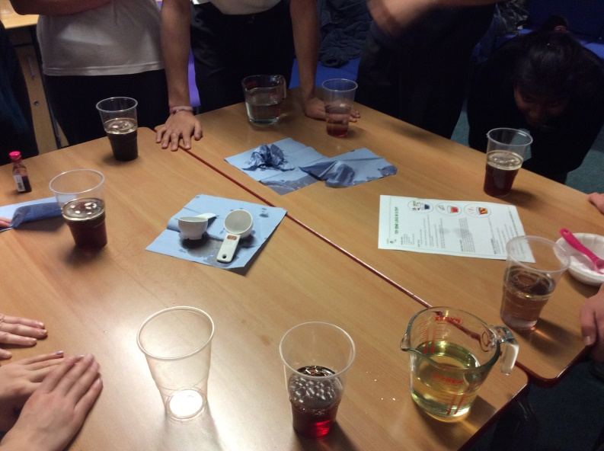
Students measuring out the right amount of oil, dye and water for their snowglobes

IMPACT ON PUPIL OUTCOMES:
While formal science learning ends in year 11, Science week allows post-16 students to continue to learn and participate in Science. For KS3 and 4 students the experiences they have are more easily recollected and can be referred to in lessons to further understanding. The format of Science week and the general open ended tasks set by teachers allow for a greater degree of creativity, problem solving and tactile experiences.
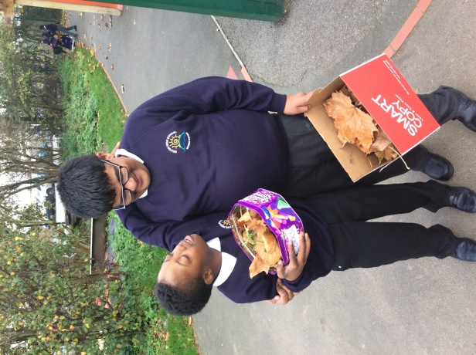
KS3 SLD class collecting natural objects for a collage from the school grounds

Learning about science outside of the formal environment of the classroom encourages our young people to continue to question how things work, outside of school lessons. In addition, having a variety of teachers (that would otherwise be linked to other subjects) teach science helps to break down context only learning and assists in the transfer of skills across the curriculum
Our young people often create objects that they can take home to share with parents, helping to further engage parents in the school community and offering a visual prompt to discuss their daily experience.
Students have a clear example of how using their voice can affect a change (e.g., adding in more trips). Lam, et al (2016) demonstrates how student involvement in a project shows our young people that “their ideas matter to others and that they have a position of responsibility to their own and their peers’ learning processes”. Despite the changes to the timetable, which are usually accompanied by anxieties reflected in disrupted behaviour, Science Week has few behaviour management issues. Our students are learning to regulate their behaviour. In addition, the further opportunities for trips outside the school grounds support social behaviour and community cohesion.
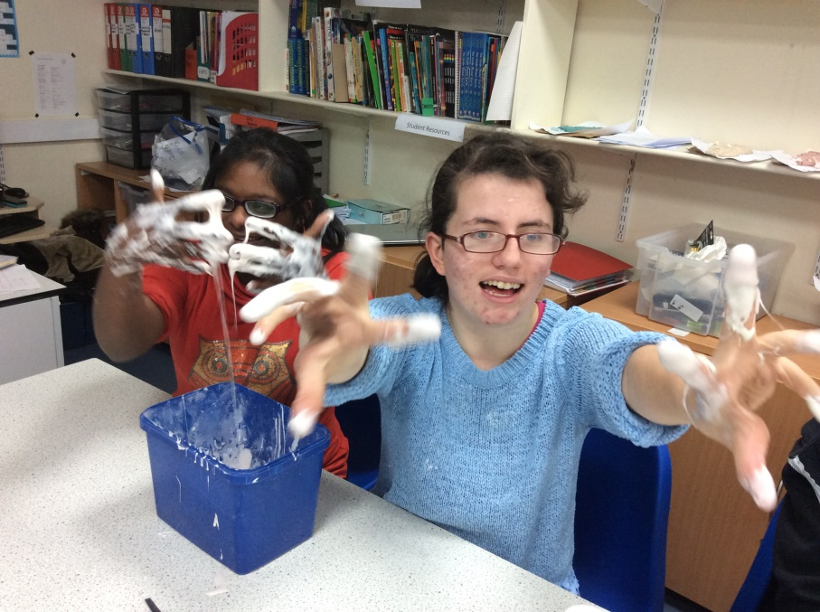
Post-16 SLD students making slime

Bibliography
Chapman, A. & Feldman, A. Cult Stud of Sci Educ (2016). Cultivation of science identity through authentic science in an urban high school.
Ofsted Report on Belvue School (2004)
Lam, R. J., Wong, L. H., Gaydos, M., Huang, J. S., Seah, L. H., Tan, M., ... & Sandoval, W. (2016). Designing learning contexts using student-generated ideas.

Day | Monday |  |  | Tuesday |  |  | Thursday |  |  | Friday
Period | 1 & 2 | 3 & 4 | 5 & 6 | 1 & 2 | 3 & 4 | 5 & 6 | 1 & 2 | 3 & 4 | 5 & 6 | 1 & 2 | 3 & 4 | 5 & 6
3MB (SL, MH ) | LD | LB | KB | PR/KW | DB/KW | LC/KW | SL/CO | WP/KW | SMk/KW | MB | PL | PR
 | Textiles | Soap Making | Comics | Where are you going? | Slime | Mug cakes | All About The Bass | Balls | Lava Lamps | Wood Games | Lemons | Treasure Hunt
 | DT | SDA | Rm 6 | Rm 7 | Science | Staff Rm | Drama | Room 8 | Rm 14 | Woods | Rm 9 | Outside
3SM & 3DN (ES, UP, Moira) | SL/CO | TN & AZB | MB | WP | LD | SW | BS | DCJ | PL | CO | SMk | LC
 | All About The Bass | Batik | Wood Games | Balls | Textiles | Eruption | Honey Comb | Wow | Lemons | Soap Making | Lava Lamps | Mug Cakes
 | Drama | Art | Woods | Rm 8 | DT | Rm 3 | Food | Science | Rm 9 | Staff Rm | Rm 14 | Staff Rm
3AK & 3JV (HS, HA) | MB | BS | SMk | AZH | SW | DB | LD | JV | SP | DCJ | AZB | LB
 | Wood Games | Honey comb | Lava Lamp | Batik | Eruption | Slime | Textiles | Medley of Experiments | Where are you going? | Wow! | Treasure Hunt | Soap making
 | Woods | Food | Rm 14 | Art | Rm 3 | Science | DT | ICT | Rm 7 | Science | Outside | Food
3MF (DB/PR) | SMk | DCJ | LC/CO | MF | KB | WP | JV | LB | SL | JG | SW | AM
 | Lava Lamps | Wow! | Mug Cakes | Treasure Hunt | Comic Book | Balls | Medley of Experiments | Soap Making | All About The Bass | Play Doh | Eruption | Paper Making/ Batik
 | Rm 14 | Rm 4 | Food | Outside | Rm 6 | Rm 8 | ICT | SDA | Drama | Room 1 | Rm 3 | Art
3GS & 3KB (SS, HB) | LC & AZH | RK | LB | Ben | AZH | PL | RK/MK | JG | MF | SP | KB | DB
 | Mug Cakes | Eruption | Soap Making | Honey Comb | Paper Making/ Batik | Lemons | Wood Games | Play Doh | Treasure Hunt | Where are you going? | Comic Book | Slime
 | SDA | Rm 3 | SDA | Food | Art | Rm 9 | Woods | Rm 4 | Outside | Rm 7 | Rm 6 | Science
4CC (MS) | WP/KW | JV/KW | MF | Smk | MB/CO | LB | KB/KW | CO | LC | AZH | JWB | SW
 | Balls | Medley of Experiments | Treasure Hunt | Lava Lamps | Wood Games | Soap Making | Comic Book | Surprise! | Mug Cakes | Paper Making/ Batik | CSI | Eruption
 | Staff Rm | ICT | Outside | Rm 14 | Woods | Food | Rm 6 | Rm 2 | Staff Rm | Art | Rm 1 | Rm 3
4LB (BG) | MF | KB | JWB | LC | LB | SMk/CO | DB | SL | WP | LD | SP | JG
 | Treasure Hunt | Comic Book | Crime Scene | Mug Cakes | Soap Making | Lava Lamp | Slime | All About The Bass | Balls | Textiles | Where are you going? | Play Doh
 | Outside | Rm 6 | Rm 1 | Staff Rm | SDA | Rm 14 | Science | Drama | Rm 8 | DT | Rm 7 | Rm 4
4SW (Sian, RF) | TN & AB | SP | AZB, MK | JV | BS | MB | SW | MF | Sian/RF | KB | DB | PL
 | Batik | Where are you going? | Lava Lamps | Medley of Experiments | Honey Comb | Wood Games | Eruption | Treasure Hunt | Surprise! | Comic Book | Slime | Lemons
 | Art | Rm 7 | Rm 3 | ICT | Food | Woods | Rm 3 | Outside | Room 3 | Rm 6 | Science | Rm 9
4WP (Nik, JH) | BS | JWB | TN & AZH | SL/CO | PR | KB | MF | SMk | CO | LC/KW | WP/KW | JV/KW
 | Honey comb | Crime Scene | Batik | All About The Bass | Where are you going? | Comic Book | Treasure Hunt | Lava Lamps | Slime | Mug Cakes | Balls | Medley of Experiments
 | Food | Rm 1 | Art | Drama | Rm 7 | Rm 6 | Outside | Rm 14 | Science | Staff Rm | Rm 8 | ICT
4TO (AG) | Agi | SL/CO | WP/KW | DCJ | AG | JV | SMK | AG | JWB | JWB | AM | LD
 | Maths | Audio | Balls | Wow | English | Medley of Experiments | Lava Lamps | English | BioMedia | BioMedia | Paper Making | Textiles
 | RM 10 | Drama | Staff Rm | Science | Rm 10 | ICT | Rm 14 | Rm 6 | Rm 10 | Rm 10 | Art | DT
5JG (JB, HH) | JG |  |  | LD | JWB | AZH | LC | PL | RK/MK | SL/CO | CO | WP
 | Science Stuff at the Litten |  |  | Textiles | CSI | Paper Making/ Batik | Mug Cakes | Lemons | Wood Games | All About The Bass | Soap Making | Balls
 | Litten |  |  | DT | Rm 1 | Art | Staff Rm | Rm 9 | Woods | Drama | SDA | Rm 8
5BS (MM, HC) | SW | DB | PL | AB, RK, MM |  |  | TN, AM | BS | JV | BS |  | MB
 | Eruption | Slime | Lemons | Litten |  |  | Batik | Honey Comb | Medley of Experiments | Foodie Friday |  | Wood Games
 | Rm 3 | Science | Rm 9 | Litten |  |  | Art | Food | ICT | Food Room |  | Woods
5SP (DB) | SP | LC | DB | SP |  |  | AB | AM | BS | PR | JV | SL/CO
 | Where are you going? | Mug Cakes | Slime | Computer Animation |  |  | Play Doh | Batik | Honey Comb | Treasure Hunt | Medley of Experiments | All About The Bass
 | Rm 7 | SDA | Science | SR room |  |  | Rm 4 | Art | Food | Outside | ICT | Drama
5SR (DP AH) | SR |  |  | SR |  |  | SR |  |  |  | JG | RK
 | Environmental Science |  |  | Environmental Science |  |  | Food Competition |  |  | Helpers | Play Doh | Wood Games
 | Outside |  |  | Outside |  |  | Southall College |  |  |  | Rm 4 | Woods

