POST 16 NEWSLETTER – OCTOBER 2017

STUDENT SURVEY
Students have just completed a survey regarding their feelings about the first half term of college. Despite having three sites and students travelling between them, the response was a fantastic 100% of students expressing their enjoyment of the first half term.

RESIDENTIAL
A place has been found at Haven Holiday Park, Pagham, Chichester, from 14th – 18th May 2018. Your child will be staying in a deluxe caravan and all their needs will be catered for including their food an activities. Please let us know as soon as possible if you would like your child to attend as the caravans need to be booked.

HM REVENUE
If anyone receives a letter from the HM Revenue requesting information regarding your child, please contact us and let us know. We have tried to contact themselves, without any joy, however, we will issue you with another letter as is requested.

MENCAP TRAVEL TRAINING AND TRAVEL SKILLS
Mencap will be contacting identified student’s parents/carers, whose child is currently on Ealing school transport, to work with them on travel training. They follow a holistic programme and will give you detailed information about how the process works.

Mencap have now also introduced a new service called ‘Travel Skills’. This service is open to all families who would like their child to be travel trained, but who is not on Ealing Transport. Unlike travel training, to and from school, this service trains young people to travel in a variety of situations. There is a cost for this package, which takes into account where the young person lives, the training you would require and the travel costs for the trainer. If you are interested please contact the school and we will pass your information on to the right team.
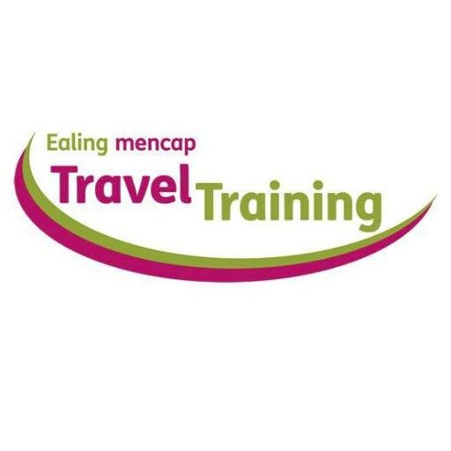
TRANSITION EVENING
This will be held on Thursday 23 November (date change) – this is an opportunity to obtain information regarding your child’s future after Post 16 by hearing from different organisations, including colleges, Mencap, NCS The Challenge and Connexions.

FUND RAISING ENTERPRISE DISCO
On Friday 3rd November, Post 16 students will be holding a disco at Belvue School as part of their enterprise to raise money for their Post 16 fund. The disco will be during the school day and the cost will be £1 per student. It is a great opportunity for students to work together as a team and use different social and communication skills to ensure they run a successful disco.

2017 STUDENT RESULTS
your child’s updated 2017 results will be sent to you in November. If your child is leaving in June 2018, these results should be taken with you when you visit or enrol for colleges in the spring term as they will want to know the level your child is.

PHONE NUMBERS & EMAILS
If you need to contact the college or any member of the team please use the information below. The office will pick up any emails and send it on to the relevant member of staff. Your child’s school diary is also a great means of communication.

Belvue = 020 8845 5766
Ken Acock = 020 8422 0372
Northolt Mobile = 07391 174013
Be aware there is only an office manager at the Ken Acock site

belvuecollege@belvue.ealing.sch.uk
REMINDER:
December 8
End of term – students are expected in school.

December 8-15
Annual Reviews – students must accompany you to their annual review. Connexions will be present to give you impartial advice about what is available for your child when they leave Belvue.

ADVANCE NOTICE:
NIGHT SCHOOL
The Post 16 Night School, is in January 2018, and will take place again at the Ken Acock site. Students remain after school until 7pm and will enjoy an evening with their peers socialising and enjoying a disco. You will need to collect your child from Ken at 7pm. There is no school transport home for students on that day.
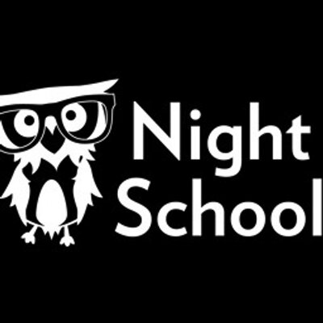

TIMETABLE OVERVIEW

Ken |  |  | Northolt |  |  | Belvue or start at Belvue |  |  | Other
Subject | Meal | Kit | Subject | Meal | Kit | Subject | Meal | Kit | Subject | Meal | Kit
Catering | School meal | kitchen whites | Independent Living | school lunch |  | Hospitality | school lunch | work uniform | Hospitality and Catering -Southall College | N/A | kitchen whites
 |  |  | Childcare | school meal  packed lunch |  | Computing Redwood | packed lunch
 |  |  | Enterprise | School lunch | Work uniform | Litten | packed lunch | work uniform
 |  |  |  |  |  | Independent Living -Southall College | packed lunch when informed
 |  |  |  |  |  | Hanwell Zoo | packed lunch | work uniform
 |  |  |  |  |  | Community Work | packed lunch | work uniform

