Smashing Glass Mini Enterprise at Belvue

BRIEF DESCRIPTION OF THE PROJECT:
The Smashing Glass Enterprise began life as a project for our Post 16 students to undertake as a working enterprise venture. At the time the school was fortunate enough to have an artist as the art teacher who specialised in the use of glass. As a result, our students were able to learn the specific skills of how to work appropriately with glass to create a range of wonderful glass pieces e.g. jewellery, mirrors, place mats, etc. This initial start-up process (selling items and taking orders during school events) progressed to our students being presented with increasing opportunities to sell their creations and glass wear at a number of local craft fairs e.g. sales at Ealing Town Hall, a local Saturday craft market. It eventually culminated in a pop-up shop in West Ealing (the Welshore Hub) where a variety of our school products were sold including cushions, made by students in their textile lessons. Students are now regularly based at the Welshore Hub each week teaching members of the public how to work safely with glass and create small pieces for themselves.
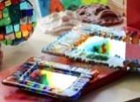
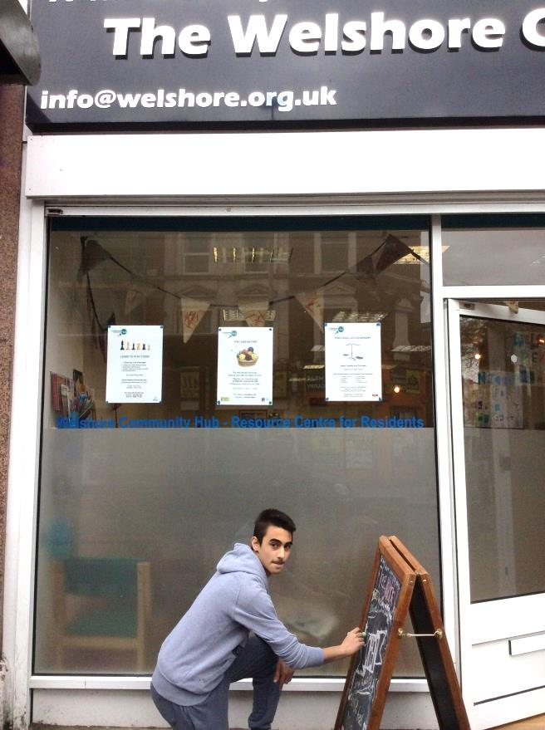

THE GOOD PRACTICE IN DETAIL (how it improved outcomes for pupils)
Drawing together aspects of an Enterprise (show initiative, creative thinking, planning, working as a team, money management) our students have all gained confidence in at least one area.

While developing these skills, students are also at the centre of a small money making enterprise that creates an income. Students have to participate in using the income to make further purchases of the resources required to create these objects.

Interacting with members of the public in order to create an item or make a sale challenges students to describe the process of making the glass and show confidence that the artefacts they have made are of value. In addition to this having the chance to teach a stranger how to achieve something is a great opportunity for them to see themselves as a valuable expert.

Students draw on and fine tune their creative abilities by designing and making a range of artefacts, predominantly using fused and appliqué glass design techniques. As they explore the range of possibilities of these techniques (jewellery, door number plates, lanterns, coasters, ornamental hangings, etc.), students begin to produce artefacts that they can then prepare for sale.

The workplace for Smashing Glass is held at The Welshore Hub in West Ealing: an ample and suitable space for our students to work and is also on the high street where it is possible for the public to walk in and see the work students are making. students have the opportunity, at times, to work with a member of the public to show them how they can cut and arrange the glass to create a design for themselves.
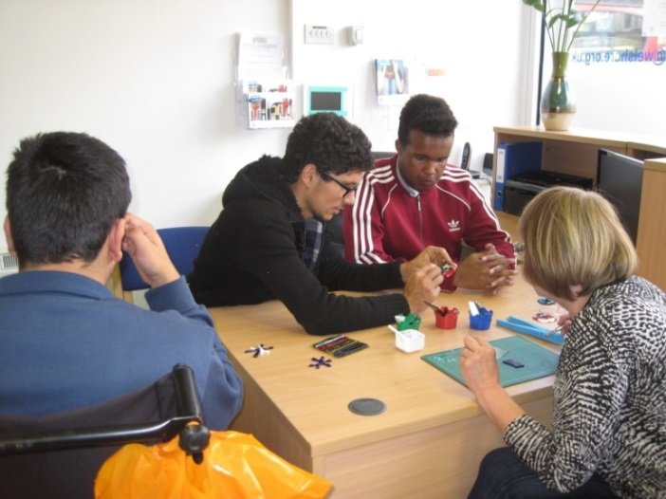

This project has helped students develop a range of vital life skills that they can use now and in the future:
- Good team work working with others - the post 16 team both staff and students alike,
- Increased and improved problem solving skills - in relation to the products and using their creative ideas, to the pricing of each piece or range,
- Good organisational skills - in regards to setting out the designs and being able to organise themselves efficiently.
- Increased communication and interaction skills - as they mix and relate with the public to sell their creative produce.

Impact on pupil outcomes:
The enterprise project has given students a clear sense of employment and the experience of the world of work.
An understanding of the importance of social and communication skills and being a part of the community and a valuable citizen in society.
A sense of achievement in creating something and being praised for that accomplishment or being able to see the result of his/her work through a sale, enables our young people to feel a realistic sense of pride and worth.
Students build self-motivation in their own ability or what they can achieve as part of a group
A deeper awareness of money and time management, both in regards to their time keeping, but also when buying stock and making ordered pieces for customers.
A clearer grasp and comprehension of functional maths in everyday life i.e. the understanding that you need to be aware when you are running low on something and need to buy a replacement in time.
The confidence of all students has increased and they are more self-assured in being a part of other fairs in the future.
