POST 16 NEWSLETTER – MARCH 2017

TRANSITION LEARNING CONVERSATIONS
Learning conversations will take place between Friday 24th – Friday 31st March. You will shortly receive the date of your appointment. It is important that all parents attend. If there is a time or date during that week please let us know and we will try our best to accommodate you, however it is not always possible due to the high number of students.
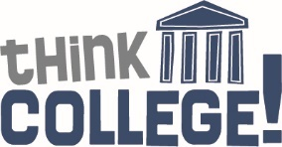
EXAM RESULTS
Student exam results (to date) will be sent out to leavers in order to share the information with perspective colleges. This year’s (and final) exam results are expected in August 2017 and final certificates are due at the end of October 2017.

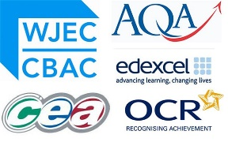

NCS THE CHALLENGE
Sadly we had an extremely poor take up of the Challenge. If you are one of the parents who did complete a form for your child, great, as he/she will have an amazing time. Please let us know if you completed a form.

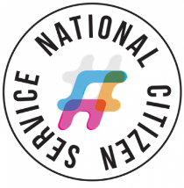
THE FELIX PROJECT
The Felix Project is an organisation that delivers food to different charities and groups of people all over London. They are now supporting us at the Ken Acock Centre – we have had our first delivery at the beginning of the month, and we are extremely pleased with this partnership. The food we receive from them is used to create a variety of even more nutritious meals for our young people.
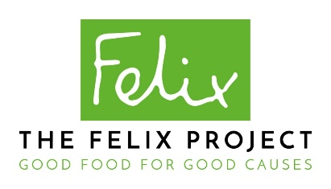
END OF TERM
The end of term for Post 16 students is Friday 24th March and school reopens on Tuesday 18th April.
Similar to last term, if you are a parent/parents who work full time and will have difficulties with child care, we will be organising some activities, at a cost, for the last week of the normal school term (Monday 27 -Friday 31 @ 1:30pm).
Let me know, as soon as possible, if you would like your child to attend.

