Establishing a School Safeguarding Group at Belvue School

BRIEF DESCRIPTION OF THE PROJECT:
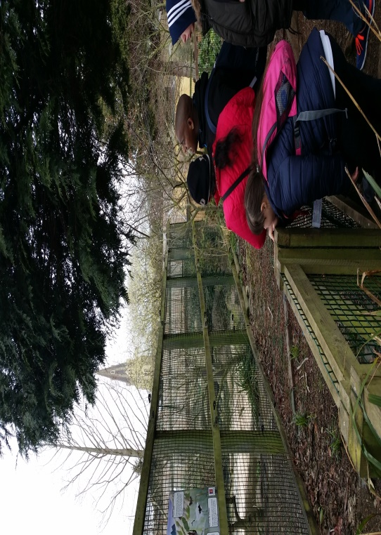
As part of the schools self-evaluation process and in response to the principles identified in the school aims:
- To provide a variety of work and other experiences in preparation for adult life in which they have the greatest possible degree of autonomy and support them in having relationships with mutual respect and dependence on each other

School data identified that many young people have little, if any contact, with their peers outside school. For many young people during the weekend their only source of entertainment is shopping or playing on their computer. School based data revealed that as many as 75% of pupils did not see anyone at the weekend outside of their own family. There was a desire therefore to provide opportunities for pupils to learn friendships skills within the context of their community. The objectives for the friendship group were therefore defined as:

To develop students understanding of the importance of friendship within the context of a healthy lifestyle.
For students to realise the leisure choices available to them outside school.
To develop students skills in organising their leisure time with friends within the local community.
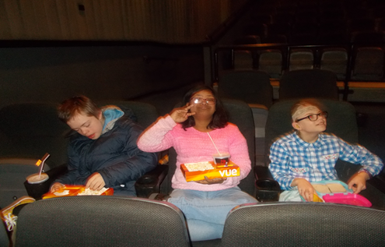
To develop students independence in making leisure choices within their community.
To help students build sustainable friendships outside school.
To support individual students development of independence skill.
To raise awareness amongst parents/carers of the importance of the development of friendship skills for these students.
Support parents/carers in their role as potential facilitators of these friendships.
To target KS4 students as part of the preparation for work experience and college
Throughout the course of each friendship programme, the friendship co-ordinator facilitates many roles including organising the group’s activities and safety. They also focus on facilitating discussion about the importance of friendship whilst supporting the acquisition of skills necessary to develop and maintain friendships, for example developing listening, conflict resolution and turn taking skills. As the group develops, the co-ordinator takes an increasingly backseat role in the activities being undertaken; but support reflection at the end of each session. They also help the group to develop the skills to become self- sustainable after the programme ends.

THE GOOD PRACTICE IN DETAIL (how it improved outcomes for pupils)

The friendship group was established with the aim of:

- Giving as many students as possible, the opportunity to develop their friendship network outside school by being supported in their friendship group, by an adult, for a period of eight to ten weeks.

- The friendship group meeting on a Saturday

- Participation in the group being on a voluntary basis.

- The worker organising the group is a teaching assistant from the school know to the young people

- The worker initially makes contact with each family to discuss the programmes and seek permission for the young person to participate. During this consultation a risk assessment is completed.
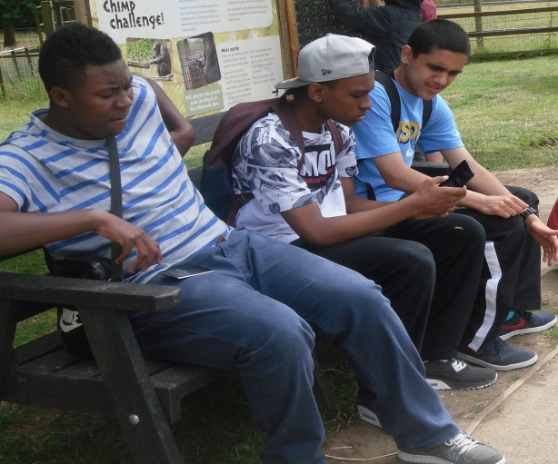
- The first meeting of the group is held in school, which allows the students to meet informally to discuss their needs and ideas for the itinerary for the their sessions together in the coming weeks. This meeting focuses on the importance of making a commitment to each other and the reasons why this commitment is important to the success of the friendship group.

- The worker then writes to all the carers informing them of the itinerary and any cost implications and the importance of supporting and encouraging their child to attend.

- The first meeting is held outside school and is normally convened at the West Side Youth Centre as the first step to promoting the use of local facilities in supporting friendship and well-being.

Impact on pupil outcomes:
- Pupils reported enjoying the opportunity to meet with their friends outside school
- Increase in the number of pupils becoming independent from 23% to 35%
- Parents reported an increase in the confidence of their child following the programme
- 98% of parents reported that the school offers a good range of activities - including the friendship group - that their child found interesting and enjoyable.

