POST 16 NEWSLETTER – MARCH 2018

COLLEGE APPLICATION
Adele, from Connexions has been re-interviewing most of the leavers. During this month she will be contacting parents in order to support your and your child with the application process.

NEW COLLEGE COURSE
Apologies that the meeting scheduled for Monday 5th had to be cancelled. It has been rescheduled for Monday 19th March. The students in Mr Prophet and Miss Gibson’s class are the targeted students.
Belvue are pleased to announce a brand new college course which is to start in September, as a result of the hard work, development and organisation from Adele Hines and a member of staff at the West London College. The course was developed in order to bridge the gap between Entry Level and Level 1 qualifications. For example, it is a course for students who have passed their Entry Level 3 in English and/or maths, but are not quite ready to achieve a Level 1 qualification.

NCS THE CHALLENGE
The Challenge has finally sent us an email. They will be coming into school on Tuesday 20th March to speak to Year 11 and 12 students (15-17 year olds) about their summer programme. Students are only allowed to go once, so if your child has already attended, unfortunately they cannot do so again.
However, if your child has attended and they are now 18 years old, they can apply to be a helper during the summer.

RESIDENTIAL
Thank you all for completing your residential payments. The deadline for the final payment has now passed. The office will be sending out more information and forms which need completing soon. Please read everything carefully and fill in and return the forms by the due dates.
.

HOMEWORK
Remember to work with your child to support them in their maths and/or English Exams by using pages in the diary and accessing different educational websites.
If unsure or need more support, please speak to the class teacher/TA.

END OF SPRING TERM
Friday 23 March is the last day of school for Post 16s. This is a normal school day and students are expected in.
Once again if you are a single working parent or both parents who work and you would like your child to remain at school until Thursday 29 March (finish 1:30) please let me know or the college office know so that we can plan the days and cost everything.

SPRING TRANSITION /LEARNING CONVERSATION
Friday 23 – Thursday 29 March are the dates of the spring Transition/Learning Conversations. This is an opportunity to discuss how your child is doing overall – socially, emotionally, physically and educationally. Connexions will be present if your child is leaving Belvue, otherwise it will be a meeting with your child’s teacher/tutor.
Dates have now been sent out. Thank you for the reply slips we have already received. We look forward to seeing you and your child at your appointment.

ADVANCE NOTICE:
LEAVERS GRADUATION/PRESENTATION EVENING
This is a grand affaire to say goodbye to all our leavers and hand out certificates of achievements to all of our students.
This will be a smaller event than previous years and will cater for only our Key Stage 4 and Post 16 students.

END OF SUMMER TERM – START OF SUMMER HOLIDAY
Friday 29 June is the last day of the school year for all Post 16 students. Hopefully a number of our students will be attending The Challenge (NCS) summer programme. This is an excellent opportunity for our young adults to engage with other young people in the borough and build some lasting memories.

Reminder
COLLEGE OPEN DAYS
Please see below a list of more college open days for you to attend with your child. Your child will not be marked absent for any college visits. It is important that you visit a number of different places in order to ‘get a feel of a place’, experience the journey and meet some of the staff.

School/ College | Address | Website | Open Days
Capel Manor College  Contact: 020 8993 6266 | Gunnersbury Park, Popes Lane, Acton, W3 8LQ | www.capel.ac.uk | Gunnersbury Park Centre  Saturday, 21 April 2018  Saturday, 16 June 2018  (Open Days start at 10.00am and finish at 3.00pm.)
Hammersmith & Fulham College (EHWL)  Contact: 020 8741 1688 | Gliddon Road, Barons Court, London W14 9BL | www.wlc.ac.uk | Tuesday 6 March 2018  Tuesday 5 June 2018  4:00pm – 8:00 pm
Gates house (EHWL) | Gliddon Road  Hammersmith  London, W14-9BL | www.wlc.ac.uk
Acton Construction and STEM Centre (EHWL)  Contact: 020 8741 1688 | Gunnersbury Lane, Acton, W3 8AE | www.wlc.ac.uk | Tuesday 13 March 2018  4:00 pm - 8:00 pm
Southall Community College (EHWL)  Contact: 020 8741 1688 | Beaconsfield Road, Southall, UB1 1DP | www.wlc.ac.uk | Wednesday 22 November 2017  Wednesday 14 March 2018  Tuesday 26 June 2018  4:00 pm - 8:00 pm
Belvue School  Contact:0208 845 5766 | Belvue School  Rowdell Road, Northolt  UB5 6AG | https://www.belvueschool.com/ | Please call school to book an appointment
Uxbridge College  Contact: 01895853333 | Park Road, Uxbridge, Middlesex, UB8 1NQ | www.uxbridge.ac.uk | Tuesday – Thursday (9:00am – 6:00pm)  Friday (9:00am – 4:00pm)
Uxbridge College  Contact: 01895853333 | College Way, Coldharbour Lane, Hayes, UB3 3BB | www.uxbridge.ac.uk | Tuesday – Thursday (9:00am – 6:00pm)  Friday (9:00am – 4:00pm)
Harrow College (Harrow-on-the-Hill) | Lowlands Road, Harrow, HA1 3AQ | www.harrow.ac.uk | For more information about Harrow College's Open Evening and the courses on offer please contact 020 8909 6000
William Morris 6th Form  Contact: 020 8748 6969 | St Dunstan’s Road, Hammersmith, W6 8RB | http://www.wma.ac.uk/ | Dates for Autumn 2017 TBC
Ambitious about Autism  Feel free to call admissions number on 020 3870 8775 to discuss further or email:- admissions@ambitiouscollege.org.uk | Pears Campus, West Thames College, London Road, Isleworth TW7 4HS | http://www.ambitiouscollege.org.uk/ | Tuesday 28 November 2017 (10:30am – midday)  Thursday 11 January 2018 (10:30am – midday)  Friday 2 February 2018 (10:30am – midday)  Thursday 15 March 2018 (10:30am – midday)  Friday 20 April 2018 (10:30am – midday)  Tuesday 22 May 2018 (10:30am – midday)  Thursday 21 June 2018 (10:30am – midday)  Tuesday 10 July 2018 (10:30am – midday)
West Thames College (Isleworth Campus)  Contact: 020 8326 2020 | London Road, Isleworth, TW7 4HS | www.west-thames.ac.uk | Wednesday 7 February 2018 (5pm – 7pm)  Saturday 24 March 2018 (10am – 1pm)
West Thames College (Feltham Campus)  For courses and apprenticeships in catering, construction, engineering and motor vehicle.  Contact: 020 8818 6800 | 77 Boundaries Road, Feltham, Middlesex TW13 5DR | www.west-thames.ac.uk | Thursday 15 March 2018 (4pm – 6pm)

PHONE NUMBERS & EMAILS
If you need to contact the college or any member of the team please use the information below. The office will pick up any emails and send it on to the relevant member of staff. Your child’s school diary is also a great means of communication.

Belvue = 020 8845 5766
Ken Acock = 020 8422 0372
Northolt Mobile = 07391 174013
Be aware there is only an office manager at the Ken Acock site

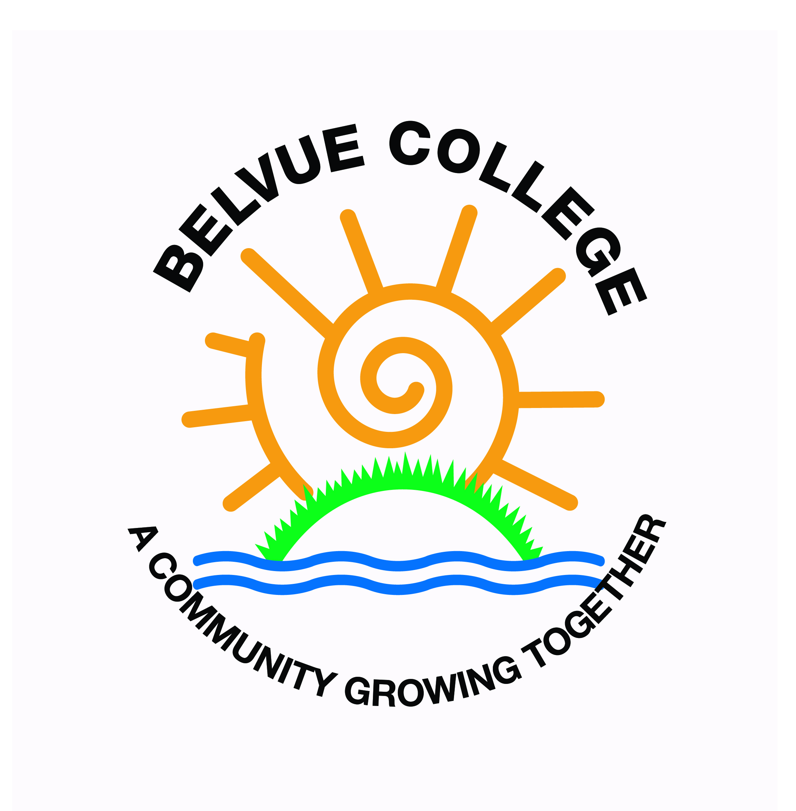
belvuecollege@belvue.ealing.sch.uk

TIMETABLE OVERVIEW

Ken |  |  | Northolt |  |  | Belvue or start at Belvue |  |  | Other
Subject | Meal | Kit | Subject | Meal | Kit | Subject | Meal | Kit | Subject | Meal | Kit
Catering | School meal | kitchen whites | Independent Living | school lunch |  | Hospitality | school lunch | work uniform | Hospitality and Catering -Southall College | N/A | kitchen whites
 |  |  | Childcare | school meal  packed lunch |  | Computing Redwood | packed lunch
 |  |  | Enterprise | school lunch  packed lunch | work uniform | Litten | packed lunch | work uniform
 |  |  |  |  |  | Independent Living -Southall College | packed lunch when informed
 |  |  |  |  |  | Hanwell Zoo | packed lunch | work uniform
 |  |  |  |  |  | Community Work | packed lunch | work uniform

